1 The effect of surface drag strength on mesocyclone intensification and

2 tornadogenesis in idealized supercell simulations

3 Brett Roberts∗ and Ming Xue†

4 Center for Analysis and Prediction of Storms and School of Meteorology, University of

5 Oklahoma, Norman, Oklahoma

6 Daniel T. Dawson II

7 Purdue University, West Lafayette, Indiana

8 Submitted to Journal of Atmospheric Sciences, April 2019

9 Revised October 2019; January 2020

10 ∗Current affiliation: Cooperative Institute for Mesoscale Meteorological Studies, Norman, OK,

11 NOAA/NWS/Storm Prediction Center, Norman, OK, and NOAA/OAR/National Severe Storms Lab-

12 oratory, Norman, OK

13 Corresponding author address: Ming Xue, Center for Analysis and Prediction of Storms, 120
†

14 David L. Boren Blvd., Norman, OK 73072.

15 E-mail: mxue@ou.edu

ABSTRACT

A suite of six idealized supercell simulations is performed in which the sur- face drag coefficient (C_{d}) is varied over a range of values from 0 to 0.05 to represent a variety of water and land surfaces. The experiments employ a new technique for enforcing a three-force balance among the pressure gra- dient, Coriolis, and frictional forces so that the environmental wind profile can remain unchanged throughout the simulation. The initial low-level meso- cyclone lowers toward the ground, intensifies, and produces a tornado in all experiments with C_{d} ≥ 0.002, with the intensification occurring earlier for larger C_{d}. In the experiment with C_{d} = 0, the low-level mesocyclone remains comparatively weak throughout the simulation and does not produce a tor- nado. Vertical cross sections through the simulated tornadoes reveal an axial downdraft which reaches the ground only in experiments with smaller C_{d}, as well as stronger corner flow in experiments with larger C_{d}. Material cir- cuits are initialized enclosing the low-level mesocyclone in each experiment and traced backward in time. Circulation budgets for these circuits implicate surface drag acting in the inflow sector of the supercell as having generated important positive circulation, and its relative contribution increases with C_{d}. However, the circulation generation is similar in magnitude for the experi- ments with C_{d} = 0.02 and 0.05, and the tornado in the latter experiment is weaker. This suggests the possible existence of an optimal range of C_{d} values 36 for promoting intense tornadoes within our experimental configuration.
37 1. Introduction

38 The role of surface drag in supercell dynamics, and particularly in tornadogenesis, continues to

39 receive heightened research interest during recent years. To a large degree, the present study repre-

40 sents an extension of Roberts et al. (2016) (hereafter R16) and Roberts and Xue (2017) (hereafter

41 RX17) that examine the effects of surface drag using a fixed drag coefficient (C_{d}) value of 0.01.
42 As such, we will first summarize those two studies for context, then briefly review relevant studies

43 over the past few years.@@

44 a. Summary of R16 and RX17@@

45 R16 performed a pair of idealized supercell simulation experiments at 50-m grid spacing using

46 the Advanced Regional Prediction System (ARPS; Xue et al. 2000, 2001, 2003) initialized with an

47 environmental sounding based on the 3 May 1999 tornado outbreak in central Oklahoma. The first

48 experiment, FWFRIC, employed the standard ARPS model formulation for surface drag where

49 drag is applied to the full near-surface horizontal wind components. The second experiment,

50 EnvFRIC, used a modified formulation where drag was effectively applied only to the base-state

51 wind profile; that is, drag acted only to maintain the environmental wind profile that was in three-

52 force balance among the horizontal pressure gradient force (PGF), Coriolis force, and surface drag,

53 and did not influence perturbation winds associated with the simulated storm. Both experiments

54 used a drag coefficient of C_{d} = 0.01. A strong tornado occurred in FWFRIC about 25 min into
55 the supecell storm simulation, while no tornado occurred in EnvFRIC during the first 40 min.

56 Vorticity budgets along tornado-entering trajectories in FWFRIC revealed strong enhancement of

57 horizontal vorticity by surface drag in the near-ground inflow east of the mesocyclone, which

58 subsequently contributed to cyclonic vorticity in the tornado after tilting and stretching when the

59 trajectories turned upward. In addition, near-ground horizontal convergence along a boundary

60 beneath the low-level mesocyclone was shown to be substantially stronger in FWFRIC than in

61 EnvFRIC during and preceding tornadogenesis. @@

62 RX17 extended the analysis of experiments FWFRIC and EnvFRIC to the low-level mesocy-

63 clone during the pre-tornadogenesis phase of the simulated storm evolution. Lagrangian circula-

64 tion budget analyses were performed to elucidate the source of circulation along evolving material

65 circuits. The material circuits were initialized around the low-level mesocyclone and traced back-

66 ward in time. The circulation budgets for the circuits in FWFRIC revealed that, for the low-level

67 mesocyclone below 1 km AGL during the 5-min period immediately preceding tornadogenesis,

68 surface drag had generated a substantial fraction of the mesocyclone circulation. The low-level

69 mesocyclone circulation in EnvFRIC during the same period, while comparable in magnitude to

70 that in FWFRIC, was predominantly barotropic in origin (i.e., it originated from the preexisting

71 environmental wind shear). In both simulations, only a weak cold pool with a small footprint

72 had developed during the period preceding tornadogenesis, and baroclinity was shown to make a

73 minimal contribution to the mesocyclone circulation. @@

74 Taken in sum, the results of R16 and RX17 illustrated a scenario of supercell evolution wherein

75 surface drag generates enhanced horizontal vorticity on the storm scale, and this vorticity is then

76 tilted and stretched to contribute meaningfully to cyclonic vorticity in the mesocyclone and tor-

77 nado. One limitation of those results is that only a single value of C_{d} was employed, so the
78 sensitivity of the mesocyclone intensification and tornadogenesis to the drag strength is unknown.

79 For example, will the tornado be increasingly stronger if the drag coefficient is increased to the

80 upper limits associated with real land surfaces, or will sufficiently strong drag weaken or even

81 eliminate the tornado? To answer these questions, the present study performs a suite of idealized

82 supercell simulations in which the drag coefficient (C_{d}) is set to zero or to values between 0.002
83 and 0.05; the non-zero values cover a representative range for drag over water and land surfaces

84 of different roughnesses. To facilitate the use of different C_{d} values in idealized storm simula-
85 tions within the same environment, a new technique is employed to keep the environmental wind

86 profile in the far field more or less unchanged throughout the simulation regardless of the value

87 of C_{d}, while still allowing drag to act on the full wind components. Effects of the drag strength
88 on the simulated storm intensity and structures, especially those pertaining to the mesocyclone

89 and ensuing tornado, are documented. The relative contributions of surface drag to the circulation

90 about mesocyclone-enclosing material circuits for different drag strengths are also analyzed and

91 compared. @@

92 b. Recent progress on supercell and tornadogenesis dynamics@@

93 In the period since the preparation of RX17, a theme in much of the new literature on the

94 tornadogenesis problem has been a return to somewhat more fundamental questions about rele-

95 vant supercell dynamics, rather than a special emphasis on which physical mechanism(s) generate

96 tornadic vorticity. For example, Coffer and Parker (2016) (hereafter CP16) examined idealized

97 single-sounding 125-m numerical simulations initialized with composites of observed soundings

98 collected during the VORTEX2 field project. Specifically, a simulation initialized using a compos-

99 ite of tornadic cases was compared against one initialized using a composite of nontornadic cases.

100 The supercell in the tornadic composite experiment produced a tornado-like vortex (TLV) with

101 EF3-strength wind speeds, while the supercell in the nontornadic composite experiment failed to

102 produce an organized TLV. This outcome was linked to the stronger low-level mesocyclone and

103 associated updraft in the tornadic composite experiment. The relatively more dominant stream-

104 wise (crosswise) vorticity near the ground in the tornadic (nontornadic) composite sounding is

105 argued, after tilting and ingest into the low-level mesocyclone, to have more effectively induced a

106 positive feedback of dynamic perturbation pressure falls aloft that gave rise to this robust updraft.

107 Implicit in this conclusion is that the environmental wind shear (and associated barotropic horizon-

108 tal vorticity) is a crucial and direct control on mesocyclone processes near and below 1 km AGL,

109 in addition to its more ubiquitously understood impact on midlevel rotation. This is noteworthy

110 because the literature on supercell dynamics has long emphasized the need for downdrafts to gen-

111 erate ”near-ground” cyclonic vorticity in a supercell. The basis for this argument is typically that

112 tilting of horizontal vorticity in near-ground parcels ascending into an updraft cannot commence

113 quickly enough to generate meaningful vertical vorticity until some appreciable height AGL (e.g.,

114 Rotunno and Klemp 1985; Davies-Jones and Brooks 1993; Markowski et al. 2008; Davies-Jones

115 2015). However, Rotunno et al. (2017) (hereafter RMB17) have cast some doubt on this notion, us-

116 ing highly idealized numerical experiments (in which a pseudostorm updraft and downdraft were

117 forced by persistent specified heating and cooling sources, respectively, and the lower boundary

118 was free-slip) to demonstrate how near-ground parcels with initially negligible vertical vorticity

119 can in fact acquire cyclonic vorticity ”near the ground” (e.g., 1 m AGL) immediately upon as-

120 cent. The key ingredient for this near-ground production is the presence of very large streamwise

121 horizontal vorticity prior to ascent; due to the action of stretching, such large streamwise vortic-

122 ity is more likely to be found in accelerating flows (e.g., an outflow surge, or inflow accelerating

123 toward the center of an intensifying mesocylone) than decelerating flows (e.g., inflow stagnating

124 upon approach to a strong, vertically erect gust front; Davies-Jones and Markowski 2013). Note

125 that in RMB17’s experiments, preexisting cyclonic vorticity prior to ascent is still beneficial for

126 subsequently generating large values near the ground, even if it is not strictly necessary. @@

127 R16 identified a mechanism for cyclonic vorticity production during trajectory descent toward

128 the ground analogous to the ”vortex line slippage” mechanism in Davies-Jones and Brooks (1993),

129 except that it is the exchange of frictional crosswise vorticity into the horizontal streamwise direc-

130 tion – rather than direct, baroclinic generation of horizontal streamwise vorticity – which initiates

131 the process during descent (c.f. Fig. 19 in R16). This mechanism, which was demonstrated for

132 a representative parcel trajectory entering the simulated tornado in R16, is one example of how

133 vorticity generated without baroclinic influence could contribute directly to tornadogenesis. If

134 the arguments of RMB17 apply to most supercells in nature, it is even possible that near-ground

135 parcels without a history of descent could contribute to substantial near-ground cyclonic vortic-

136 ity in low-level mesocyclones and tornadoes¹; in principle, this would further open the door to
137 important generation mechanisms other than baroclinity (e.g., frictional generation, or tilting and

138 stretching of environmental vorticity). Considering that frictionally-generated horizontal vortic-

139 ity is largest near the ground, and previous modeling studies (Schenkman et al. 2014, R16) have

140 shown that the so-called ”riverbend effect” can convert much of the initially crosswise frictional

141 vorticity possessed by tornado-bound parcels into streamwise vorticity as the flow curves cycloni-

142 cally and converges toward the vortex (after which tilting into the vertical and amplification from

143 stretching can be expected upon ascent into the vortex), it is clear that further investigation into

144 frictional effects on supercell dynamics and tornadogenesis is warranted. @@

145 Coffer and Parker (2018) (hereafter CP18) conducted an expanded suite of idealized experiments

146 initialized with intermediate soundings interpolated between the CP16 tornadic and nontornadic

147 composite profiles, finding a ”tipping point” where TLV-genesis occurs if the background envi-

148 ronment is comprised of at least 40% of the tornadic composite. Again, the role of the low-level

149 environmental horizontal vorticity magnitude and orientation (in particular, the 0-500 m AGL

150 storm-relative helicity) in promoting a robust low-level mesocyclone is identified as the key causal

151 factor for this tipping point. CP18 state among their key conclusions that ”operationally, it mat-

1Although both parcels analyzed in RMB17 descended prior to acquiring cyclonic vorticity, their results demonstrate a key physical mechanism (large stretching of horizontal streamwise vorticity prior to ascent) which could also manifest in parcels accelerating horizontally near the ground without a history of participation in a downdraft.

152 ters not how vertical vorticity is generated at the surface,” so long as a strong low-level updraft

153 exists to stretch the vorticity sufficiently upon ascent. This is a finding echoed by Yokota et al.

154 (2018, hereafter Y18), who conducted a 33-member ensemble of 50-m real-data simulations of

155 the 6 May 2012 Tsukuba, Japan, supercell tornado case. Circulation analyses for circuits ini-

156 tialized encircling tornadoes in various members, then integrated backward in time, revealed that

157 friction tended to have a larger overall contribution to circulation than baroclinity; nonetheless,

158 baroclinity was a dominant source of tornadic circulation in some members. Furthermore, the

159 relative roles of different circulation generation mechanisms within an ensemble member were

160 not strongly correlated with the existence or intensity of a tornado in that member. Instead, Y18

161 found ”tornadogenesis was especially well correlated with the strength of low-level mesocyclones

162 at about 1 km AGL and water vapor near the surface” in the minutes prior to genesis. The crit-

163 ical role of the low-level mesocyclone and updraft strength was also seen in RX17 and several

164 other high-resolution modeling studies (e.g., Noda and Niino 2010; Mashiko 2016), with RX17

165 placing particular emphasis on the effect of horizontal vorticity generated by surface drag on the

166 mesocyclone intensity. Trapp et al. (2017) has argued using a simple mathematical model that

167 the updraft width, in addition to strength, may also control tornado intensity. A commonality of

168 these studies is the critical role played by the low-level mesocyclone, which provides the needed

169 intense vertical stretching. Meanwhile, these studies also point to the important role of the vertical

170 shear/horizontal vorticity contained in the flow feeding the mesocyclone, which may come from

171 the background environment or be generated/enhanced by the storm (e.g., through baroclinity or

172 surface friction). These findings motivate a particular focus on the dynamics and evolution of

173 the low-level mesocyclone in the present study across our suite of experiments with different C_{d}
174 values. @@

175 As fundamental conceptual models of supercell behavior are evolving to accommodate new in-

176 sights and experimental results, identification of specific vorticity generation mechanisms acting

177 on parcels bound for the low-level mesocyclone and tornado remains an important facet of under-

178 standing their dynamics. Furthermore, in the case of surface drag, any potential role it might play

179 in important vorticity generation has potential operational relevance, since the surface roughness

180 beneath and surrounding a supercell can in many cases be reasonably assessed in real time. Thus,

181 our continued work in this area has both academic and operational relevance. @@

182 The rest of this paper is organized as follows. Section 2 briefly describes the new technique for

183 maintaining the environmental wind profile, and how it differs from the experimental setup in R16.

184 Section 3 presents the results of our new experiments. Section 4 summarizes the results, discusses

185 their implications, and suggests possible areas of future research. @@

186 2. Methodology@@

187 a. Environmental wind balance technique@@

188 When compared to experiments FWFRIC and EnvFRIC analyzed in R16 and RX17 (described

189 in Section 1a), the simulations analyzed in the present study differ chiefly in our approach to

190 modeling the force balance in the background environment, and also in the actual value of the

191 surface drag coefficient. @@

192 In Section 2b of R16, we detailed a procedure for establishing a base-state sounding which is in

193 a three-force balance among the horizontal PGF, Coriolis force, and frictional force (the so-called

194 “geotriptic” balance; Johnson Jr. 1966). In the current study, we will refer to the force-balancing

195 technique from R16 as the frictional balancing procedure (FBP). As a brief review, the FBP in-

196 volved integrating a 1D version of the ARPS model (the same model used for the 3D storm simu-

197 lations, with the same vertical grid spacing and physics parameterizations) for a 48-h adjustment

198 period. The 1D simulation was initialized with a sounding extracted from a real-data simulation

199 of the 3 May 1999 tornado outbreak in central Oklahoma conducted by Dawson et al. (2010)

200 (hereafter DA10); this initial sounding (called MAY3) was assumed to be in geostrophic balance,

201 even though drag acting within the modeled planetary boundary layer (PBL) qualitatively vio-

202 lated this assumption. The 1D simulation effectively included the large-scale PGF, Coriolis force,

203 and surface drag (using C_{d} = 0.01, which was selected as an intermediate value representative of
204 land). After the 48-h adjustment, a three-force balance was achieved in the 1D column, and the

205 resulting thermodynamic and kinematic profiles were taken as a sounding we called MAY3B (Fig.

206 1). In R16 and RX17, MAY3B was used to define the storm environment in 3D storm simula-

207 tion experiments (FWFRIC and EnvFRIC) that used C_{d} = 0.01. By employing the FBP, R16 and
208 RX17 compared the application of parameterized surface drag to the full wind (FWFRIC) versus

209 its application to only the base-state wind (EnvFRIC). The action of surface drag within the 1D

210 adjustment simulation resulted in a substantial change in the low-level wind profile of MAY3B,

211 when compared to the original MAY3 sounding. MAY3B consequently contains an excess of
212 near-ground shear (e.g., 0-1 km storm-relative helicity of 435 m² s⁻² in MAY3B vs. 310 m²
213 s⁻² in MAY3) that is attributable directly to the assumption of MAY3’s geostrophy in the FBP.
214 Furthermore, this change in low-level shear was necessarily dependent on the magnitude of C_{d},
215 meaning that different choices of C_{d} would have yielded different shear profiles. Therefore, with
216 the FBP method, it was not possible to run experiments varying C_{d} while keeping the same envi-
217 ronmental wind profile balanced in all of the simulations. It is the goal of this study to overcome

218 this limitation and examine the impact of different C_{d} values on storms developing within the same
219 environment. @@

220 In the present study, the FBP is supplanted by a new approach called the geotriptic wind bal-

221 ance (GWB) technique introduced in a companion paper (Dawson et al. 2019, hereafter DRX19).

222 Briefly, its purpose is to make practical the use of any sounding to define the storm environment

223 for idealized simulations with surface drag using a constant drag coefficient C_{d}. It accomplishes
224 this by explicitly adding a compensating horizontally uniform force to the horizontal momentum

225 equations that balances the Coriolis and friction forces on the large scale (i.e., for the unperturbed

226 storm environment). This compensating force (hereafter the “pseudo-PGF” or PPGF) is found by

227 evaluating the time tendency of the horizontal momentum equations under the action of Corio-

228 lis and frictional forces, typically using a suitable horizontal average of an unperturbed region of

229 the domain near the beginning of the simulation. The required force is then the negative of this

230 time tendency. The PPGF so computed is added immediately back to the RHS of the horizontal

231 momentum equations for the initial time step and all subsequent times. In this manner, the GWB

232 technique will ensure the background environment (i.e., the far field away from storm-induced per-

233 turbations) remains in three-force balance, and therefore quasi-steady state, for any background

234 sounding. @@

235 Along with this property, another advantage of the GWB technique over the FBP technique

236 makes it ideal for the purposes of the study: while the FBP is only physically justifiable to the

237 extent that the initial input sounding is in geostrophic balance, this is not the case when using

238 the GWB technique, since it explicitly assumes the initial profile is in three-force balance (i.e.

239 Coriolis, PGF, and friction) and is thus more flexible. We refer the reader to DRX19 for further

240 details. In the present study, we apply a range of C_{d} values to experiments which all share the same
241 initial sounding (MAY3B). Thus, in these experiments, we do not claim to model the three-force

242 balance from the real storm environment which produced MAY3B. Instead, as in R16 and RX17,

243 we are artificially forcing the background environment to remain the same over different surfaces

244 in order to discern the impact of drag specifically on storm perturbations. @@

245 b. Experimental design and model configuration@@

246 In this study, six experiments with different drag coefficient values are performed using the

247 GWB technique. For continuity with FWFRIC and EnvFRIC (from R16 and RX17; more details in

248 Section 1a) and to facilitate clean comparisons with those earlier experiments, the initial sounding

249 for all experiments herein is MAY3B (Fig. 1). We therefore again emphasize the caveat that

250 MAY3B contains some degree of artificially enhanced near-ground shear when compared with

251 DA10’s original simulation, as described in Section 2a. @@

252 The experiments and their drag coefficients are summarized in Table 1, along with representative

253 land surfaces for each coefficient². These experiments are intended to sample the parameter space
254 spanned by land surfaces over which supercells may exist in the real world, ranging from short

255 grassland to tall forests and urban cores (with the exception of CD0, which represents an idealized

256 frictionless surface). Experiment CD0 is the GWB-based equivalent to EnvFRIC; that is, drag does

257 not act on storm perturbations in CD0, even though its background wind profile has resulted from

258 drag. In the remaining experiments, drag does act on the storm perturbations, but the magnitude

259 varies according to C_{d}. Experiment CD1-2, with C_{d} = 0.01 (1 x 10⁻²), is the GWB-based equivalent
260 to FWFRIC. Although CD0 (CD1-2) is not identical in evolution to EnvFRIC (FWFRIC), they are

261 qualitatively very similar throughout the analysis period. @@

262 Our numerical simulations are conducted using the Advanced Regional Prediction System

263 (ARPS) (Xue et al. 2000, 2001) with the same configuration described in R16, aside from the

2Note that only roughness length z₀ can be linked directly to land surface types, while C_{d} in a numerical model is a function of both z₀ and the height of the lowest scalar grid level z₁ (10 m AGL, in our configuration). See eq. (4) of Wieringa (1993) for details.

264 implementation of the GWB technique and our specified values of C_{d}. The grid spacing is 50-m
265 in the horizontal. There are 83 vertical levels, and vertical grid spacing ranges from 20-m near

266 the ground to 400-m in the upper troposphere. The physical domain is 64x96 km in horizontal

267 extent and 16 km deep in the vertical. For this study, simulations were integrated in time to 3000

268 s. The initial condition is horizontally homogeneous (defined by the aforementioned sounding

269 MAY3B) except for an ellipsoidal thermal bubble with a maximum potential temperature pertur-

270 bation of 6 K (used to initiate deep moist convection). Parameterization of microphysics follows

271 the five-species formulation of Lin et al. (1983), but with the rain intercept parameter (n_{0r}) re-
272 duced to 2x10⁶. The 1.5-order TKE formulation of Moeng and Wyngaard (1988) is employed to
273 parameterize subgrid-scale turbulence. @@

274 3. Simulation results@@

275 a. Overview and qualitative analysis@@

276 As with the original FWFRIC and EnvFRIC experiments from R16 (described at length in Sec-

277 tion 1a), all six experiments evolve qualitatively similarly to each other for the first 600 s. Sub-

278 sequently, as with those two experiments, subtle differences in the near-ground wind field begin

279 to grow during the 600-1200 s period, yielding more qualitatively meaningful differences by 1500

280 s. Fig. 2a presents a time series of domain-wide³ minimum perturbation pressure for the GWB
281 experiments. All experiments with drag enabled (C_{d} > 0) exhibit large pressure deficits of 40-80
282 hPa during the 1500-2200 s time period. A tendency exists for an experiment’s largest deficit to

283 occur earlier as C_{d} increases (e.g., CD2-2 reaches its minimum around 1500 s, whereas CD2-3
284 reaches its minimum around 2000 s). CD0 stands in stark contrast to the drag-enabled experi-

3Note that in Fig. 2, although plotted values are domain-wide extrema, larger magnitudes are almost always associated with the low-level mesocyclone region and/or tornado.

285 ments, with pressure deficits remaining smaller than 25 hPa throughout the period. Among the

286 drag-enabled experiments, pressure deficits in CD5-2 are substantially smaller than in the other

287 experiments. A time series of maximum storm-relative horizontal winds (Fig. 2b) also reveals that

288 wind maxima tend to be larger, and occur earlier in time, in the experiments with larger C_{d} (ex-
289 cept for the largest value). The differences in maximum wind magnitude between the strong-drag

290 and weak-drag experiments are somewhat less pronounced than the corresponding differences in

291 pressure deficits, however, as wind speeds associated with strong outflows and other non-tornadic

292 features can also become quite large (e.g., even CD0 reaches a maximum of 80 m s ⁻¹ around 2800
293 s, and this strong flow is not associated with a near-surface vortex; Fig. 2c). A corresponding

294 time series of maximum vertical vorticity below 2 km AGL (Fig. 2c) tracks the inter-experiment

295 timing and magnitude differences of the perturbation pressure minima quite closely, including the

296 relatively weak maxima in CD5-2 when compared to the other drag-enabled experiments. The

297 storm features responsible for these discrepancies will now be shown and discussed. @@

298 Fig. 3 presents domain-wide time-height cross sections from 0-3000 s of maximum updraft and

299 vertical vorticity for the six experiments. The initial lowering of the mesocyclone from around

300 1500 m AGL toward the ground can be seen in the plots of updraft magnitude (Fig. 3a-f) to begin

301 earlier during the simulation as C_{d} increases. Similar to FWFRIC in R16, large cyclonic vorticity
302 develops quickly upward from the ground in all experiments except CD0 during the 1300-1800

303 s period (Fig. 3g-l). This process occurs progressively earlier with increasing C_{d} from 0.001
304 in CD2-3 to 0.02 in CD2-2, but there is little difference in timing between CD2-2 and CD5-2.

305 Based on these cross-sections, it appears that surface drag (with a C_{d} value as small as 0.002) is
306 required in order for an intense low-level mesocyclone to develop during this early stage of the

307 simulation, and that larger values generally hasten this process. However, at the high end of the

308 sampled C_{d} parameter space, there exist signs of an upper limit on favorability for intense low-

309 level mesocyclogenesis somewhere in the range 0.02 ≤ C_{d} ≤ 0.05. Although the lowering of the
310 mesocyclone occurs slightly earlier in CD5-2 than in CD2-2, the maximum mesocyclone updraft
311 and vorticity are weaker overall in CD5-2, and intense rotation (ζ ≥ 0.75 s⁻¹) does not extend
312 above 300 m AGL (Fig. 3d-e, i-j). This may be due to the increasingly large damping effect on

313 the near-surface flow as the surface drag increases in strength. @@

314 Horizontal cross-sections of horizontal convergence, perturbation pressure, and ground-relative

315 wind vectors at 1320 s are presented in Fig. 4. In CD0, a broad zone of convergence is seen along

316 the surface boundary, which is primarily north-south oriented and separates westerly and easterly

317 flow (Fig. 4a). As C_{d} increases in the remaining experiments, a few trends are noted. First, the
318 surface boundary becomes progressively more curved along its northern extent around (x = 36

319 km, y = 65 km). Second, the convergence zone becomes more compact, with a larger maximum

320 convergence magnitude at its center (except in CD5-2, where maximum convergence is weaker

321 than in all other drag-enabled experiments). Third, the inflow low (denoted by the innermost per-

322 turbation pressure contour) east of the boundary becomes centered more toward the northwest. In

323 CD2-2 and CD5-2, a strong pressure minimum associated with a developing tornado can already

324 be seen near (x = 36 km, y = 64 km) (Fig. 4e-f). All of these trends largely mirror the discrep-

325 ancies between EnvFRIC and FWFRIC analyzed in R16 (see their Fig. 4). The relatively orderly

326 changes with increasing C_{d} between CD0 and CD2-2 bolster confidence that the early-simulation
327 convergence boundary behavior in FWFRIC and EnvFRIC is predictable and representative of

328 monotonic trends within the C_{d} parameter space. By contrast, the markedly weaker convergence
329 maximum in CD5-2 relative to CD2-2 is another indication that surface drag in CD5-2 is so strong

330 as to interfere⁴ with processes that encourage more intense low-level mesocyclogenesis and tor-
331 nadogenesis during this period in CD2-2 (Fig. 4e-f). The ground-relative flow on both sides of the

4A tornado occurs shortly after this time in both CD2-2 and CD5-2, but its intensity is much greater in CD2-2 (c.f. Fig. 2).

332 boundary, and particularly within the inflow east of the boundary, is so weak in CD5-2 (Fig. 4f)

333 that low-level convergence is relatively anemic, and this proves detrimental to low-level updraft

334 maintenance (Fig. 3e). @@

335 Fig. 5 displays horizontal cross-sections at 10 m AGL and 1800 s, revealing the extent and

336 strength of the surface cold pool and tornado (except in CD0, where no tornado is ongoing at 1800

337 s). At 1800 s, the surface convergence boundary remains more north-south oriented in experiments

338 with smaller C_{d}, whereas experiments with larger C_{d} tend to exhibit a strongly curved boundary
339 that wraps into the tornado. It is noteworthy that relatively warm air resulting from a dynamically-

340 driven downdraft south of the mesocyclone (e.g., centered near [x = 32 km, y = 63 km] in Fig.

341 5a) tends to wrap cyclonically around the mesocyclone and partially encircle the tornado in the

342 experiments with larger C_{d}, whereas the surface boundary south of the mesocyclone in CD0 (and,
343 to a much lesser extent, CD2-3) appears to block this warm air from wrapping in. @@

344 As discussed previously in R16 and RX17, the timing of tornadogenesis in our experiments

345 (about 25-35 min after the introduction of a thermal bubble to induce an updraft) is quite early

346 in the parent storm’s life cycle. The 3D numerical experiments of Markowski (2016) with pre-

347 dominantly crosswise near-ground environmental vorticity exhibited similarly rapid genesis of a

348 tornado-like vortex, although his experiments were dry and used a much more idealized setup than

349 those in the present study (e.g., while using generally realistic supercell wind profiles, his ”pseu-

350 dostorms” were forced and modulated by an artificial heat source and sink that produced an updraft

351 and downdraft). While a few comparable cases of very rapid tornadogenesis following convective

352 initiation have been documented in real observations (e.g., Palmer et al. 2011; Boustead and Gross

353 2016), the preponderance of evidence suggests most tornadoes forming via supercell mesocyclone

354 processes occur later into the storm life cycle – and with a cooler, more expansive rear-flank down-

355 draft (RFD) adjacent to the low-level rotation (e.g., Lemon and Doswell 1979; Markowski 2002),

356 providing greater opportunity for the influence of baroclinic vorticity (e.g., Klemp and Rotunno

357 1983; Rotunno and Klemp 1985; Markowski et al. 2008) – when compared to our simulations

358 herein. Thus, there is reason for caution in broadly applying conclusions regarding the precursors,

359 dynamics, and evolution of our simulated tornadoes and low-level mesocyclones to their coun-

360 terparts in real-world supercells. As in R16 and RX17, we stress that our findings through the

361 remainder of this section should be interpreted as evidence of the physical plausibility of dynam-

362 ically similar vortices within supercells, rather than as necessarily representative of all (or even

363 most) supercell tornadoes in nature. Indeed, extensions of our simulations herein to 4800 s ex-

364 hibit a second period of tornado development after a significant cold pool becomes established

365 (not shown); baroclinic vorticity generation is expected to play a larger role alongside frictional

366 generation under such conditions. These results will be analyzed and reported in future work. @@

367 b. Tornado structure@@

368 Next, we examine how the tornado-scale structure varies among our experiments, to the extent it

369 is resolved on our grid. Fig. 6 presents pseudo-vertical cross-sections of vertical velocity, vertical

370 vorticity, and wind vectors through the first tornado occurring in the drag-enabled experiments

371 (CD2-3, CD5-3, CD1-2, CD2-2, and CD5-3; note that CD0 is excluded in this section because

372 it does not produce a tornado). At each vertical grid level, a horizontal slice of grid points along
373 the x-axis is extracted along the y-coordinate containing the local minimum in p^{t}; these linear
374 slices are then stacked vertically to produce the pseudo-vertical sections in Fig. 6. Effectively, this

375 means that the cross-section tilts meridionally with height to keep the tornado center within the

376 cross-section plane. Although the cross-sections are taken near the time of peak tornado intensity

377 (as defined by the minimum pressure deficit) in each experiment, it must be cautioned that some

378 discrepancies between panels may be time-dependent and/or associated with storm-scale differ-

379 ences not directly tied to the vortex’s interaction with the lower boundary; for this reason, we will

380 present more spatiotemporally general statistics below. Nonetheless, the corner flow (Rotunno

381 1977; Lewellen et al. 2000) is more pronounced in CD2-2 and CD5-2 (Fig. 6d-e) than in CD2-3

382 and CD5-3 (Fig. 6a-b). Consequently, strong (>30 m s⁻¹) updraft within the vortex tends to extend
383 downward closer to the ground in experiments with larger C_{d}. In CD2-3, which uses the smallest
384 C_{d} among the drag-enabled experiments, the tornado’s primary updraft is elevated and fed by flow
385 which turns upward with a relatively large curvature radius in the x-z plane; w > 30 m s⁻¹ only
386 occurs above 400 m AGL (Fig. 6a). @@

387 Evidence of marginally resolved multi-vortex structure near the ground exists to varying de-

388 grees in CD5-3 (Fig. 6b), CD1-2 (Fig. 6c), and CD2-2 (Fig. 6d); by contrast, the tornado in

389 CD5-2 features a core axial updraft at the lowest grid levels AGL, supported by horizontal flow

390 there converging sharply from the east and west (Fig. 6e). For context, horizontal cross-sections

391 through the vortex at 50 m AGL of vertical velocity, perturbation pressure, and ground-relative

392 wind vectors are presented in Fig. 7. Downdraft exists at or near the tornado center in CD2-3 (Fig.

393 7a), CD5-3 (Fig. 7b), and CD1-2 (Fig. 7c); by contrast, updraft dominates the entire inner vortex

394 at this height in CD2-2 (Fig. 7d) and CD5-2 (Fig. 7e). @@

395 The trends with respect to corner flow and tornado-scale variations in w seen within our C_{d} pa-
396 rameter space broadly agree with Trapp (2000) (hereafter T00), who performed idealized axisym-

397 metric vortex simulations with free-slip and no-slip lower boundary conditions. A key finding

398 in T00 was that an axial (central) downdraft penetrated to the surface almost immediately after

399 vortex-genesis in their free-slip simulation, but was dislodged aloft in their no-slip simulation by

400 an intense axial jet erupting upward from the ground. Radial inflow resulting from surface friction

401 disrupting cyclostrophic balance gives rise to this axial jet (Bluestein 2007); with all other vari-

402 ables held constant, larger C_{d} should tend to enhance this effect, as the magnitude of the frictional

403 force increases relative to other forces acting on near-ground parcels at the periphery of the vortex,

404 in turn leading to increased radial inflow. Indeed, the tornado is characterized by a strong central

405 updraft within the first 1-3 grid levels AGL in CD2-2 and CD5-2, but not in the weak-drag exper-

406 iments; these differences are also evidenced in the time-height sections (Fig. 3a-e), which reveal

407 a stronger updraft below 100 m AGL in CD2-2 and CD5-2 compared with the other experiments.

408 This greater propensity for single-vortex structure over rough surfaces was also demonstrated in

409 the tornado-like vortex laboratory experiments of Leslie (1977): a larger imposed swirl ratio was

410 required to drive a transition from single- to multiple-vortex structure when the surface rough-

411 ness was increased artificially in the laboratory chamber. Church et al. (1979) found comparable

412 results in a separate laboratory experiment, concluding that ”...the swirl ratio is the internal pa-

413 rameter which primarily determines the [vortex] core configuration ... [but] the surface boundary

414 layer plays a significant yet secondary ... role.” Finally, these results are also consistent with recent

415 idealized numerical simulations of tornadoes interacting with changes in local surface roughness

416 (Lewellen 2014). @@

417 More recently, Fiedler (2017) (hereafter F17) conducted idealized experiments of an axisym-

418 metric vortex with varying lower boundary conditions (including, effectively, multiple drag coeffi-

419 cients for the semi-slip boundary condition) to predict how simulated tornadoes should behave in

420 full 3D cloud models such as that used in the present study. F17 ”anticipate[s] that a cloud model

421 with C_{d} = 0.01 ... will produce tornadoes ... that would have properties close to being free-slip”
422 in structure; specifically, downdraft would be expected to penetrate down to ground level. Indeed,

423 in CD1-2, strong downdraft exists in the vortex core near the ground at the time of peak intensity

424 (Fig. 6c). Other experiments in F17 which effectively employed C_{d} = 0.03 and 0.1 showed the
425 axial downdraft dislodged upward from the ground at most angular velocities tested (c.f. their

426 Figs. 3-4), matching the results herein for CD2-2 and CD5-2 (Fig. 6d-e). @@

427 Fig. 8a presents vertical profiles of vertical mass flux through a 350x350 m horizontal box

428 centered on the tornado in each experiment. The profiles represent 1-min averages ending at the
429 time in each experiment when p^{t} within the tornado reaches its minimum (c.f. Fig. 2a). At each
430 grid level and at each time, the box is centered on the grid point where p^{t} is a local minimum.
431 The upward mass flux increases monotonically with C_{d} within the lowest 70 m AGL, despite the
432 fact that overall tornado intensity does not exhibit this monotonic increase (indeed, well away

433 from the ground at 300 m AGL, the largest upward flux is actually found in the weakest-drag

434 experiment). A similar trend is found for the time-average maximum w inside the 350x350 m box

435 (Fig. 8b). Furthermore, when examining time-average minimum w inside the box, evidence of

436 axial downdraft penetrating down to the lowest 50 m AGL is most prevalent in CD2-3 and CD5-

437 3; modest downdraft also occurs above 30 m AGL in CD1-2. By contrast, downdraft is entirely

438 absent below 100 m AGL in CD2-2 and CD5-2. These results mirror aspects of Nolan et al. (2017),

439 who showed in very high-resolution idealized 3D LES tornado simulations that the maximum

440 updraft speed at 10 m AGL in their vorticies increased markedly with surface roughness (among

441 three experiments with z₀ = 0.05, 0.2, and 0.8 m; c.f. their Table 3). To the extent that our time-
442 averaged profiles in Fig. 8 represent the overall tornado behavior in each experiment, our results

443 support the arguments of T00 and confirm that high-resolution storm-scale numerical simulations

444 can reproduce certain aspects of tornadic structure previously identified in highly idealized vortex

445 models with artificial forcing. @@

446 c. Circulation analysis of early mesocyclone@@

447 In order to examine the dynamics of mesocyclone intensification, material circuits will once

448 again be employed, as in RX17. In this case, it is of particular interest to determine whether the

449 contribution to mesocyclone circulation from surface drag increases in an orderly fashion as C_{d}

450 increases. The procedure for initializing the circuits, as well as for calculating circulation and its

451 forcing terms along the circuit, is the same as in RX17 in most respects; a brief review follows here.

452 Horizontal circular circuits of radius 1.5 km are initialized centered on the low-level mesocyclone

453 (determined subjectively from the model wind field) with parcels approximately 19 m apart. These

454 parcels are integrated backward in time as trajectories; when the distance between adjacent parcels

455 exceeds 25 m after an integration time step, a new parcel is added to the circuit at the midpoint of

456 the line segment connecting those parcels, and is then included at all subsequent (backward) time

457 steps. We integrate circuits backward in time for 600 s (10 min) at a time step of 0.5 s (afforded

458 by linear temporal interpolation of the wind between model data files, which are available every

459 2 s). After integration, the relevant state variables are interpolated to parcel locations in order to

460 compute the circuit’s circulation and circulation forcing terms at each model data time (every 2

461 s). One notable difference from RX17 is that the GWB technique, which applies a PPGF and the

462 Coriolis force, introduces new terms into the prognostic circulation equation for a circuit such that:

= F · dl + B dz + P · dl − (2Ω × v) · dl (1)
dC
dt
463 where F is the total mixing force; B is buoyancy; P is the PPGF (as specified by the GWB tech-
464 nique); Ω is Earth’s rotation; v is the velocity vector; dl is a circuit segment (directed counter-
465 clockwise); and dz is the vertical component of the segment. From left to right, the RHS terms

466 in (1) represent circulation forcing from mixing, baroclinity, the PPGF, and Coriolis⁵. Note that
467 F represents the net action of subgrid-scale turbulence and numerical diffusion on the velocity
468 components; when a parcel is near the ground and C_{d} > 0, the effects of surface drag typically
469 dominate this term. @@

470 In the present study, we initialize circuits in each experiment across an array of initial heights

471 and times. For each experiment, we initialize a circuit at three heights (500 m, 1000 m, and

5In our simulations, Coriolis is calculated with the domain’s center latitude taken to be 36◦N.

472 2000 m AGL) at four times (1200 s, 1260 s, 1320 s, 1380 s); this yields 12 total circuits per

473 experiment. Our goal is to track how the forcing terms affect the low-level mesocyclone circulation

474 during its period of initial intensification. Dahl et al. (2012) discussed the increased uncertainty

475 associated with trajectories in 3D numerical simulations on the C-grid (Arakawa and Lamb 1977)

476 which pass below the lowest scalar grid level AGL. While it is often possible to select trajectories

477 for which this conundrum does not apply when analyzing individual parcels (e.g., R16), it is

478 impractical to do so for a large material circuit integrated over a duration of 10 min, considering

479 the number of parcels entailed. Consequently, as in RX17, we accept that some constituent parcels

480 will pass below 10 m AGL (the height of our first scalar level); in such cases, all interpolated scalar

481 quantities and horizontal momentum components are taken to be their values directly above the

482 parcel at 10 m AGL (note that w and its forcing terms are defined on the C-grid at the lower

483 boundary, obviating the need for this special treatment). This treatment avoids extrapolation, but

484 we still expect increased errors in both the trajectory position and interpolated quantities (e.g., for

485 our circulation budgets) when it is applied. An analysis of the height distribution for all parcels

486 comprising our circuits (not shown) revealed that, at any given time, no more than 12% of parcels

487 resided below 10 m AGL for any circuit; a more typical proportion during the early part of the

488 integration windows was 5%. In practice, we expect analysis of these circuits to yield qualitatively

489 valid results when their interpolated (i.e., model-predicted) circulation agrees reasonably well with

490 the circulation integrated from source terms throughout the budget integration period. @@

491 Fig. 9 presents bar charts showing the integrated circulation contributions from the mixing

492 (a,b,c) and baroclinic (d,e,f) forcing terms over the preceding 10 min, normalized by the circuit’s

493 final circulation value⁶ (the PPGF and Coriolis forcing terms are omitted for clarity here, as the

6The quantities plotted are given as the ratio of the circulation generated by the forcing term during the 10-min integration period to the

instantaneous value of the circuit’s circulation at the end of the integration period; this ratio is expressed as a percentage for clarity.

494 former is an artifact of our simulation approach and the latter is typically too small to be of inter-

495 est in supercell dynamics). It should be emphasized that each initial circuit time labeled on the

496 abscissa represents a unique set of circuits (e.g., the four yellow bars in Fig. 9a represent the nor-

497 malized mixing contribution for four unique circuits in CD5-2; not the time evolution of a single

498 circuit in CD5-2). Nonetheless, within a given experiment and at a given initial height, we take

499 the series of four circuits initialized at 60-s intervals between 1200-1380 s to represent the time

500 evolution of certain bulk mesocyclone properties – in particular, the proportion of mesocyclone

501 circulation generated by mixing and baroclinity. @@

502 For circuits initialized at 500 m AGL, the mixing term imparts a net negative contribution of

503 15-30% of the mesocyclone’s circulation for each of the initialization times in experiments CD0

504 and CD2-3; the relative magnitudes of these contributions generally remain steady with time over

505 the period (Fig. 9a). By contrast, the mesocyclone in CD5-3, CD1-2, CD2-2, and CD5-2 sees an

506 increased contribution with time from the mixing term during the same period. For CD5-3, the

507 contribution at 1200 s is weakly negative, but becomes weakly positive by 1380 s. For CD2-2

508 and CD5-2, the mixing contribution at 1200 s is small but positive, but grows increasingly large

509 with time; by 1380 s, mixing generation accounts for 40% to 50% of the circuits’ circulation.

510 In all experiments and at all times, the contribution from baroclinity is small, accounting for no

511 more than 10% (negative or positive) of the final circulation (Fig. 9d). We believe the increase

512 in the relative contribution of mixing with time in CD5-3, CD1-2, CD2-2, and CD5-2 owes to the

513 same positive feedback process described at length in RX17 (for experiment FWFRIC therein):

514 as the low-level mesocyclone begins to intensify, the coincident low-level updraft strengthens

515 dynamically, allowing more frictional vorticity residing in the lowest few hundred meters AGL

516 to be ingested into the circulation; this, in turn, enhances the mesocyclone in a positive feedback

517 loop. @@

518 For the circuits initialized at 1000 m AGL, a similar trend in the mixing term contribution with

519 time and with C_{d} is seen (Fig. 9b), albeit with smaller relative magnitudes than for the circuits
520 at 500 m AGL. One notable difference at 1000 m AGL is that, by the time of rapid mesocyclone

521 intensification at 1380 s, mixing is actually more effective at generating positive circulation in

522 CD2-2 than in CD5-2. Once again, as was true at 500 m AGL, baroclinity plays only a small

523 role in generating circulation for the mesocyclone at 1000 m AGL (Fig. 9e). Finally, at 2000 m

524 AGL, the contribution of the mixing term is smaller still in magnitude and less correlated with

525 time or C_{d} (Fig. 9c) than at lower heights. Except for CD2-2, where mixing is a 10-20% positive
526 contribution by 1320 s and 1380 s, mixing contributions for other circuits are small and of the same

527 order of magnitude as baroclinity (Fig. 9f). We note that while the circuits initialized at 2000 m

528 AGL contain only a small relative contribution from frictional generation, it is possible that more

529 substantial such generation occurred earlier in the simulation than our 10-min integration window

530 (e.g., if constituent parcels were located near the ground >10 min before our circuit initialization

531 time but ascended thereafter, our integration window would potentially miss important frictional

532 generation). @@

533 The trend for the mixing term to provide a more positive contribution to the low-level mesocy-

534 clone circulation as C_{d} increases is expected, based on the mechanism identified in RX17 wherein
535 surface drag slows the southwestward-directed momentum of near-ground inflow parcels while

536 parcels higher above are less affected by the surface drag. To better understand the physical mech-

537 anisms responsible for the mixing contributions shown in Fig. 9a, three-dimensional circuits are

538 plotted in Fig. 10, with each inter-parcel segment shaded by its local per-unit-length contribution

539 to the mixing term. While the circuits plotted were initialized around the mesocyclone at 1380 s

540 and 500 m AGL in each experiment, their positions are plotted at 1140 s (4 min into their back-

541 ward integration). As seen in circulation budgets for these circuits (Fig. 11), the magnitude of

542 the mixing term tends to be maximized around this time (1140 s), regardless of whether its sign is

543 predominantly positive (CD5-3, CD1-2, CD2-2, and CD5-2) or negative (CD0 and CD2-3) during

544 the integration window. It is apparent in Fig. 10 that the circuits in all six experiments contain a

545 long segment lying near the ground toward their southeastern extent, similar to circuits previously

546 analyzed in EnvFRIC and FWFRIC (c.f. Fig. 9 in RX17). Along most of this near-ground seg-

547 ment, which lies in the inflow region east of the mesocyclone, the sign of the local mixing term

548 reflects the predominant sign seen in Fig. 9a and Fig. 11 for the total circuit generation term. In

549 all experiments, some locally large values of this generation term are seen along higher portions of

550 the circuit toward its northwestern extent, but these tend to manifest as offsetting dipoles with op-

551 posite signs on the upward- and downward-directed circuit segments. Thus, the long near-ground

552 circuit segment in the inflow region appears primarily responsible for the net forcing from mixing

553 in each experiment, implicating the effects of surface drag (or lack thereof in CD0). These budgets

554 further corroborate the conceptual model of the frictional generation mechanism from RX17 (e.g.,

555 their Fig. 15) and verify its presence over the C_{d} parameter space we examine herein: in CD5-3,
556 CD1-2, CD2-2, and CD5-2, surface drag is acting against northeasterly⁷ near-ground flow in the
557 inflow region. This decelerates flow that is locally consistent with clockwise (negative) circulation

558 about the circuit, thus increasing the total circulation. The same mechanism acts on the circuits

559 at 1000 m AGL, but it constitutes a relatively smaller portion of the final circulation (Fig. 9b),

560 because the circuit is farther away from ground and thus less affected by surface drag. At 2000 m

561 AGL, mixing has only a modest impact on circulation overall (Fig. 9c). @@

562 A noteworthy result is that, in the absence of drag, mixing imposes a substantial negative con-

563 tribution to the final circulation at 500-1000 m AGL in CD0; this is also true to a lesser extent in

564 CD2-3 with weak drag. As discussed in M16 (see their Fig. 24) and supported in RX17, internal

7Here we refer to northeasterly flow in a ground-relative sense, as seen in Fig. 4.

565 mixing typically acts to dampen local vorticity maxima (e.g., the large horizontal vorticity in the

566 inflow region east of the mesocyclone). The circulation budgets at 500 m AGL for CD0 suggest

567 this effect can act to impart a negative contribution of as much as 25-30% to the circuits’ circula-

568 tion during their approach to the low-level mesocyclone (e.g., Fig. 9a). This provides a baseline

569 which puts the mixing contribution for the other experiments into context: in experiments CD2-2

570 and CD5-2, where the mixing term provides a 40-50% positive net contribution to circulation, the

571 final circulation is perhaps as much as 150% larger than might be expected in the absence of drag⁸.
572 Even in CD5-3, where mixing has just a small positive net contribution to the mesocyclone circu-

573 lation at 1380 s, surface drag itself is likely still generating substantial circulation (e.g., Fig. 10c)

574 that is mostly offset by the diffusive effects of internal mixing. One caveat to interpreting the mix-

575 ing forcing in CD0 as a baseline for the other experiments is that agreement between its circuit’s

576 interpolated and integrated circulation budgets is only modest (Fig. 11a). Note that some disagree-

577 ment between interpolated and integrated circulation is unavoidable due to numerical errors often

578 related to near-grid-scale features. @@

579 4. Summary and conclusions@@

580 In this study, a new method (Dawson et al. 2019) was employed for maintaining a three-force

581 balance among the horizontal PGF, Coriolis force, and frictional force in the background envi-

582 ronment of idealized single-sounding 3D storm simulations. This geotriptic wind balance (GWB)

583 technique allows the use of an arbitrary initial sounding in simulations which use parameterized

584 surface drag with constant drag coefficient C_{d}; without the GWB, surface drag would act to mod-
585 ify the background wind profile over time throughout the domain, particularly near the ground.

8This assumes (1) the same initial circuit position and subsequent trajectory, (2) the same initial circulation at the beginning of the integration window, (3) similarly negligible contributions from PPGF and Coriolis, and (4) that diffusive effects alone would impart the same 25-30% negative
contribution during the integration window as seen in CD0.

586 The GWB technique was employed in six idealized supercell simulations whose drag coefficients
587 spanned the range 0 ≤ C_{d} ≤ 0.05. All the simulations with nonzero drag coefficients produced
588 a low-level mesocyclone 1200-1800 s into the simulation which lowered toward the ground and

589 eventually spawned a strong tornado, similar to experiment FWFRIC in RX17. The experiment

590 with C_{d} = 0 was very similar to EnvFRIC in RX17, and did not produce a tornado nor an intense
591 near-ground mesocyclone during this period. @@

592 Material circuits were initialized enclosing the low-level mesocyclone during its early intensifi-

593 cation phase, integrated backward in time, and circulation budgets were calculated. These budgets

594 suggest surface drag contributed a larger positive proportion of the total circulation for circuits in

595 the experiments with larger drag coefficients during this early mesocyclone intensification period.

596 Furthermore, the budgets for circuits in CD0 reveal that in the absence of surface drag, mixing

597 processes (turbulence mixing and numerical diffusion) commonly imposed a substantial (15-25%

598 below 1 km AGL) negative contribution to circulation on circuits bound for the low-level mesocy-

599 clone (note that the surface drag effect is propagated into the interior flow from the ground surface 600 through the turbulence mixing terms in the numerical model). Thus, the positive net contribution 601 from mixing seen in the strong-drag experiments suggests the beneficial effect of surface drag was 602 large enough to overcome a baseline negative contribution from other mixing effects. @@
603 Additionally, vertical cross-sections through the tornadoes (in experiments which produced 604 them) revealed structure consistent in some respects with previous laboratory experiments (Ward 605 1972) and numerical simulations using axisymmetric models with surface drag (Trapp 2000; 606 Fiedler 2017). Specifically, radial inflow along the ground toward the center of tornadoes in the 607 strong-drag experiments was substantially stronger than those in the weak-drag and no-drag ex- 608 periments. Also, an axial downdraft in the tornadoes penetrated down to the first grid level AGL in

609 the experiments with smaller C_{d}; in the two strongest-drag experiments, however, this downdraft
610 was dislodged upward at least two grid levels AGL. @@

611 Following R16 and RX17, the experiments in the present study strengthen some of our ear- 612 lier key findings regarding mesocyclone and tornado behavior in the presence or absence of sur- 613 face drag. In the most important respects (e.g., timing of intensification and lowering toward the 614 ground), the low-level mesocyclone behavior changed monotonically and fairly predictably with 615 C_{d} over the range of values tested herein, up until the strongest-drag experiment (CD5-2) with 616 a drag coefficient of 0.05. Given the decreased intensity of the tornado and low-level updraft in 617 CD5-2 relative to CD2-2, we infer that for the bulk drag parameterization used in most current 618 atmospheric models, the optimal value of C_{d} for generating an intense near-ground mesocyclone 619 in conditions similar to ours lies between 0.01 and 0.05. Although C_{d} was spatially homogeneous 620 in our simulations, given the circulation analyses presented in Fig. 10, it is likely that the drag 621 strength in the inflow region of the supercell was the dominant control on generation of important 622 circulation (although in the general case, this same effect could occur in other regions of the storm 623 [e.g., the RFD], provided parcels originating there subsequently enter the tornado). This broadly 624 agrees with some aspects of Reames and Stensrud (2018) (hereafter RS18), who produced a 108- 625 member ensemble of 500-m real-data simulations based on the 31 May 2013 El Reno, Oklahoma, 626 supercell; in each member, land surface properties corresponding to the Dallas-Fort Worth urban 627 area were specified over a different patch of the domain, with the remainder of the 250x250 km 628 domain comprised of grassland. RS18 found typically on the order of a 50% surplus in 0-1 km 629 storm-relative helicity over the urban area, and ensemble members with the urban area placed 630 south and southeast of the simulated storm track had a particular tendency toward a more intense 631 second mesocyclone cycle (after storm maturity) than other members. The simulations in RS18 632 used real (heterogeneous) data for their initial condition, were much coarser than ours in hori-

633 zontal resolution, and employed a PBL parameterization for boundary layer mixing instead of 634 three-dimensional subgrid-scale turbulence mixing as in our LES type simulations; their results 635 thus provide somewhat independent support for the notion that land surfaces beneath or near a 636 supercell’s inflow region with strong drag may enhance mesocyclone intensity. To the extent this 637 notion is valid, it could provide a crucial opportunity for operational meteorologists to consider 638 land surface properties in anticipating supercell behavior on short timescales. However, the rele- 639 vance of these results to the real world, and even to numerical simulations across a broad range of 640 environmental conditions, is subject to further investigation. For example, Markowski and Bryan 641 (2016) (hereafter MB16) illustrated the potential for overestimation of near-surface shear in LES 642 when the modeled flow does not contain resolved eddies, an issue which may have some relevance 643 to the simulations in the present study⁹. Most recently, Markowski et al. (2019) (hereafter M19) 644 have discussed reasons for caution in applying conventional formulations of the ”semi-slip” lower 645 boundary condition in severe storm simulations, owing in part to field observations of larger ver- 646 tical shear in the surface layer than is assumed in these formulations. However, M19 note that 647 while field observations suggest the near-ground shear in typical storm outflow may severely vi- 648 olate those assumptions, violations in the inflow region and background environment are usually 649 milder. With this considered, we believe that our results are at least qualitatively correct, espe- 650 cially in terms of the trend of surface drag dependency; using a more sophisticated (but currently 651 unavailable) drag parameterization would most likely yield results with similar trends and key 652 mechanisms (although storm and vortex behavior at particular values of C_{d} is perhaps likely to 653 change). @@

9A constant wind profile with height was specified in the initial conditions of MB16’s idealized experiments, thus requiring an Ekman layer to develop from scratch during their simulations. It is therefore likely that the overestimation of near-wall shear demonstrated in MB16 was more severe than in our present study, given that we initialize with a realistic wind profile that has already been subject to the effects of surface drag, and
we do not require the model to create a boundary layer.

654 The results presented in this study constitute a step forward toward understanding surface drag’s 655 role in supercell tornadogenesis dynamics, but many steps remain. One such step is to perform ex- 656 periments similar to those presented herein for a range of different initial soundings, which should 657 help to illuminate which of our results are generalizable to most storms. Another step is to de- 658 crease the horizontal grid spacing by a factor of 2 or 3 to better resolve tornadoes; cross-sections 659 presented herein showed indications that our grid is just fine enough to simulate some semblance 660 of multiple-vortex structure (e.g., Fig. 6), but that the subvortices are only marginally resolved, 661 yielding unrealistic details. Adding more vertical grid levels within the lowest 100 m AGL could 662 also prove immensely helpful in calculating vorticity and circulation budgets along trajectories 663 and circuits bound for tornadoes and low-level mesocyclones, as we have found such parcels tend 664 to originate from below 10 m AGL (our lowest scalar level) quite often. The higher vertical reso- 665 lution near the surface can also better resolve vertical wind shear there and may make the results 666 less sensitive to the surface layer drag parameterization. The simulations herein also still contain 667 mostly laminar flow in the inflow region, which could be subject to developing exaggerated near- 668 ground shear as described by MB16. Thus, it may be desirable to eliminate this caveat by inducing 669 turbulence in the far field with small thermal perturbations (Muoz-Esparza et al. 2014; Markowski 670 and Bryan 2016; Dawson et al. 2019). Perhaps most crucially of all, borrowing more sophisticated 671 surface layer parameterizations from the engineering community (as suggested by M19) is a chal- 672 lenging but necessary step toward bolstering confidence that our storm simulations are reflecting 673 the influence of drag realistically. If these considerations are addressed in the course of designing 674 future idealized supercell simulations, then alongside real-data modeling studies and observational 675 efforts, we are optimistic that an important component of the tornadogenesis problem – the relative 676 importance of surface drag in generating tornadic vorticity across the full distribution of real-world 677 tornado cases – may soon come into clearer focus. @@

678 Acknowledgments. This work was supported by NSF grants AGS-1261776, AGS-1917701, and 679 NOAA VORTEX-SE grant NA17OAR4590188, and NSFC grant 41730965. Numerical simula- 680 tions were performed at the Texas Advanced Supercomputing Center, an NSF XSEDE facility. 681 Portions of this work previously appeared in the Ph.D dissertation of the first author (Roberts 682 2017). The authors wish to thank four anonymous reviewers for insightful critiques of the 683 manuscript, which led to substantial improvements and additions. @@

684 References

685 Arakawa, A., and V. R. Lamb, 1977: Computational design of the basic dynamical processes 686 of the UCLA General Circulation Model. General Circulation Models of the Atmosphere, 687 J. CHANG, Ed., Methods in Computational Physics: Advances in Research and Applica- 688 tions, Vol. 17, Elsevier, 173 – 265, doi:10.1016/B978-0-12-460817-7.50009-4, URL http:
689 //www.sciencedirect.com/science/article/pii/B9780124608177500094. @@

690 Bluestein, H. B., 2007: Advances in applications of the physics of fluids to se- 691 vere weather systems. Reports on Progress in Physics, 70 (8), 1259–1323, doi:10. 692 1088/0034-4885/70/8/R01, URL http://stacks.iop.org/0034-4885/70/i=8/a=R01?key=crossref. 693 05d2ae3a032ebf189370597e6dd5cd11. @@

694 Boustead, J. M., and K. L. R. Gross, 2016: Environmental factors in the varying length of time 695 between first echo and first tornado. Amer. Meteor. Soc., Portland, OR, 49, URL https://ams. 696 confex.com/ams/28SLS/webprogram/Paper300651.html. @@

697 Church, C. R., J. T. Snow, G. L. Baker, and E. M. Agee, 1979: Characteristics of tornado-like

698 vortices as a function of swirl ratio: A laboratory investigation. Journal of the Atmospheric Sci-

699 | ences, 36 (9), 1755–1776, doi:10.1175/1520-0469(1979)036(1755:COTLVA)2.0.CO;2, URL
700 | https://doi.org/10.1175/1520-0469(1979)036(1755:COTLVA)2.0.CO;2. @@
701 | Coffer, B. E., and M. D. Parker, 2016: Simulated supercells in nontornadic and tor-
702 | nadic VORTEX2 environments. Monthly Weather Review, 145 (1), 149–180, doi:10.1175/
703 | MWR-D-16-0226.1, URL https://doi.org/10.1175/MWR-D-16-0226.1. @@
704 | Coffer, B. E., and M. D. Parker, 2018: Is there a tipping point between simulated nontornadic and
705 | tornadic supercells in VORTEX2 environments? Monthly Weather Review, 146 (8), 2667–2693,
706 | doi:10.1175/MWR-D-18-0050.1, URL https://doi.org/10.1175/MWR-D-18-0050.1. @@
707 | Dahl, J. M. L., M. D. Parker, and L. J. Wicker, 2012: Uncertainties in trajectory calcula-
708 | tions within near-surface mesocyclones of simulated supercells. Monthly Weather Review,
709 | 140 (9), 2959–2966, doi:10.1175/MWR-D-12-00131.1, URL http://journals.ametsoc.org/doi/
710 | abs/10.1175/MWR-D-12-00131.1. @@
711 | Davies-Jones, R., 2015: A review of supercell and tornado dynamics. Atmospheric Research,
712 | 158-159, 274–291, doi:10.1016/j.atmosres.2014.04.007, URL http://linkinghub.elsevier.com/
713 | retrieve/pii/S0169809514001756. @@
714 | Davies-Jones, R., and H. Brooks, 1993: Mesocyclogenesis from a theoretical perspective. Wash-
715 | ington DC American Geophysical Union Geophysical Monograph Series, 79, 105–114, doi:
716 | 10.1029/GM079p0105. @@
717 | Davies-Jones, R., and P. Markowski, 2013: Lifting of ambient air by density currents in
718 | sheared environments. Journal of the Atmospheric Sciences, 70 (4), 1204–1215, doi:10.1175/
719 | JAS-D-12-0149.1, URL http://journals.ametsoc.org/doi/abs/10.1175/JAS-D-12-0149.1. @@

720 Dawson, D. T., B. Roberts, and M. Xue, 2019: A method to control the environmental wind 721 profile in idealized simulations of deep convection with surface friction. Monthly Weather 722 Review, 147 (11), 3935–3954, doi:10.1175/MWR-D-18-0462.1, URL https://doi.org/10.1175/
723 MWR-D-18-0462.1. @@

724 Dawson, D. T., M. Xue, J. A. Milbrandt, and M. K. Yau, 2010: Comparison of Evapora- 725 tion and Cold Pool Development between Single-Moment and Multimoment Bulk Micro- 726 physics Schemes in Idealized Simulations of Tornadic Thunderstorms. Monthly Weather Re- 727 view, 138 (4), 1152–1171, doi:10.1175/2009MWR2956.1, URL http://journals.ametsoc.org/
728 doi/abs/10.1175/2009MWR2956.1. @@

729 Fiedler, B. H., 2017: Axisymmetric tornado simulations with a semi-slip boundary. Fluids, 2 (4),
730 doi:10.3390/fluids2040068, URL http://www.mdpi.com/2311-5521/2/4/68. @@

731 Johnson Jr., W. B., 1966: The ”geotriptic wind”. Bulletin of the American Meteorological Society,

732 47 (12), 982. @@

733 Klemp, J. B., and R. Rotunno, 1983: A study of the tornadic region within a su-

734 percell thunderstorm. Journal of the Atmospheric Sciences, 40 (2), 359–377, doi:
735 10.1175/1520-0469(1983)040(0359:ASOTTR)2.0.CO;2, URL https://doi.org/10.1175/
736 1520-0469(1983)040(0359:ASOTTR)2.0.CO;2. @@

737 Lemon, L. R., and C. A. Doswell, 1979: Severe thunderstorm evolution and mesocy-

738 clone structure as related to tornadogenesis. Monthly Weather Review, 107 (9), 1184–
739 1197, doi:10.1175/1520-0493(1979)107(1184:STEAMS)2.0.CO;2, URL https://doi.org/10.
740 1175/1520-0493(1979)107(1184:STEAMS)2.0.CO;2. @@

741 | Leslie, F. W., 1977: Surface roughness effects on suction vortex formation: A lab-
742 | oratory simulation. Journal of the Atmospheric Sciences, 34 (7), 1022–1027, doi:
743 | 10.1175/1520-0469(1977)034(1022:SREOSV)2.0.CO;2, URL https://doi.org/10.1175/
744 | 1520-0469(1977)034(1022:SREOSV)2.0.CO;2. @@
745 | Lewellen, D. C., 2014: Local roughness effects on tornado dynamics. Amer. Meteor. Soc., Madi-
746 | son, WI, 15A.1, URL https://ams.confex.com/ams/27SLS/webprogram/Paper254357.html. @@
747 | Lewellen, D. C., W. S. Lewellen, and J. Xia, 2000: The influence of a local swirl ratio
748 | on tornado intensification near the surface. Journal of the Atmospheric Sciences, 57 (4),
749 | 527–544, URL http://journals.ametsoc.org/doi/abs/10.1175/1520-0469(2000)057%3C0527%
750 | 3ATIOALS%3E2.0.CO%3B2. @@
751 | Lin, Y.-L., R. D. Farley, and H. D. Orville, 1983: Bulk parameterization of the snow field in
752 | a cloud model. Journal of Climate and Applied Meteorology, 22 (6), 1065–1092, doi:10.1175/
753 | 1520-0450(1983)022(1065:BPOTSF)2.0.CO;2, URL https://doi.org/10.1175/1520-0450(1983)
754 | 022(1065:BPOTSF)2.0.CO;2. @@
755 | Markowski, P., Y. Richardson, E. Rasmussen, J. Straka, R. Davies-Jones, and R. J. Trapp, 2008:
756 | Vortex Lines within Low-Level Mesocyclones Obtained from Pseudo-Dual-Doppler Radar Ob-
757 | servations. Monthly Weather Review, 136 (9), 3513–3535, doi:10.1175/2008MWR2315.1, URL
758 | http://journals.ametsoc.org/doi/abs/10.1175/2008MWR2315.1. @@
759 | Markowski, P. M., 2002: Hook echoes and rear-flank downdrafts: A review. Monthly Weather
760 | Review, 130 (4), 852–876, URL http://journals.ametsoc.org/doi/abs/10.1175/1520-0493(2002)
761 | 130%3C0852:HEARFD%3E2.0.CO%3B2. @@

762 Markowski, P. M., 2016: An idealized numerical simulation investigation of the effects of surface 763 drag on the development of near-surface vertical vorticity in supercell thunderstorms. Journal 764 of the Atmospheric Sciences, 73 (11), 4349–4385, doi:10.1175/JAS-D-16-0150.1, URL http:
765 //journals.ametsoc.org/doi/10.1175/JAS-D-16-0150.1. @@

766 Markowski, P. M., and G. H. Bryan, 2016: LES of laminar flow in the PBL: A potential problem 767 for convective storm simulations. Monthly Weather Review, 144 (5), 1841–1850, doi:10.1175/ 768 MWR-D-15-0439.1, URL http://journals.ametsoc.org/doi/10.1175/MWR-D-15-0439.1. @@
769 Markowski, P. M., N. T. Lis, D. D. Turner, T. R. Lee, and M. S. Buban, 2019: Observations 770 of near-surface vertical wind profiles and vertical momentum fluxes from VORTEX-SE 2017: 771 Comparisons to MoninObukhov similarity theory. Monthly Weather Review, 0 (0), null, doi: 772 10.1175/MWR-D-19-0091.1, URL https://doi.org/10.1175/MWR-D-19-0091.1. @@
773 Mashiko, W., 2016: A Numerical Study of the 6 May 2012 Tsukuba City Supercell Tornado. 774 Part I: Vorticity Sources of Low-Level and Midlevel Mesocyclones. Monthly Weather Review, 775 144 (3), 1069–1092, doi:10.1175/MWR-D-15-0123.1, URL http://journals.ametsoc.org/doi/10.
776 1175/MWR-D-15-0123.1. @@

777 Moeng, C.-H., and J. C. Wyngaard, 1988: Spectral analysis of large-eddy simulations

778 of the convective boundary layer. Journal of the Atmospheric Sciences, 45 (23), 3573–
779 3587, doi:10.1175/1520-0469(1988)045(3573:SAOLES)2.0.CO;2, URL https://doi.org/10.
780 1175/1520-0469(1988)045(3573:SAOLES)2.0.CO;2. @@
781 Muoz-Esparza, D., B. Kosovi, J. Mirocha, and J. van Beeck, 2014: Bridging the transition from 782 mesoscale to microscale turbulence in numerical weather prediction models. Boundary-Layer 783 Meteorology, 153 (3), 409–440, doi:10.1007/s10546-014-9956-9, URL https://doi.org/10.1007/
784 s10546-014-9956-9. @@
785 Noda, A. T., and H. Niino, 2010: A Numerical Investigation of a Supercell Tornado: Genesis and 786 Vorticity Budget. Journal of the Meteorological Society of Japan. Ser. II, 88 (2), 135–159, doi: 787 10.2151/jmsj.2010-203, URL https://www.jstage.jst.go.jp/article/jmsj/88/2/88 2 135/ article. @@

788 Nolan, D. S., N. A. Dahl, G. H. Bryan, and R. Rotunno, 2017: Tornado vortex structure, intensity, 789 and surface wind gusts in large-eddy simulations with fully developed turbulence. Journal of 790 the Atmospheric Sciences, 74 (5), 1573–1597, doi:10.1175/JAS-D-16-0258.1, URL https://doi.
791 org/10.1175/JAS-D-16-0258.1. @@

792 Palmer, R. D., and Coauthors, 2011: Observations of the 10 May 2010 Tornado Outbreak Using 793 OU-PRIME: Potential for New Science with High-Resolution Polarimetric Radar. Bulletin of 794 the American Meteorological Society, 92 (7), 871–891, doi:10.1175/2011BAMS3125.1, URL
795 http://journals.ametsoc.org/doi/abs/10.1175/2011BAMS3125.1. @@

796 Reames, L. J., and D. J. Stensrud, 2018: Influence of a Great Plains urban environment on a simu-

797 lated supercell. Monthly Weather Review, 146 (5), 1437–1462, doi:10.1175/MWR-D-17-0284.
798 1, URL https://doi.org/10.1175/MWR-D-17-0284.1. @@

799 Roberts, B., 2017: The role of surface drag in supercell tornadogenesis and mesocyclogenesis: 800 studies based on idealized numerical simulations. Ph.D Dissertation, University of Oklahoma, 801 Norman, OK, URL https://shareok.org/handle/11244/50736. @@

802 Roberts, B., and M. Xue, 2017: The role of surface drag in mesocyclone intensification lead- 803 ing to tornadogenesis within an idealized supercell simulation. Journal of the Atmospheric Sci- 804 ences, 74 (9), 3055–3077, doi:10.1175/JAS-D-16-0364.1, URL http://journals.ametsoc.org/doi/
805 10.1175/JAS-D-16-0364.1. @@
806 Roberts, B., M. Xue, A. D. Schenkman, and D. T. Dawson, 2016: The role of surface drag 807 in tornadogenesis within an idealized supercell simulation. Journal of the Atmospheric Sci- 808 ences, 73 (9), 3371–3395, doi:10.1175/JAS-D-15-0332.1, URL http://journals.ametsoc.org/doi/
809 10.1175/JAS-D-15-0332.1. @@

810 Rotunno, R., 1977: Numerical Simulation of a Laboratory Vortex. Journal of the Atmospheric Sci-
811 ences, 34 (12), 1942–1956, doi:10.1175/1520-0469(1977)034(1942:NSOALV)2.0.CO;2, URL
812 https://doi.org/10.1175/1520-0469(1977)034(1942:NSOALV)2.0.CO;2. @@

813 Rotunno, R., and J. Klemp, 1985: On the Rotation and Propagation of Simu-

814 lated Supercell Thunderstorms. Journal of the Atmospheric Sciences, 42 (3), 271–
815 292, doi:10.1175/1520-0469(1985)042(0271:OTRAPO)2.0.CO;2, URL https://doi.org/10.
816 1175/1520-0469(1985)042(0271:OTRAPO)2.0.CO;2. @@

817 Rotunno, R., P. M. Markowski, and G. H. Bryan, 2017: Near ground vertical vorticity in supercell 818 thunderstorm models. Journal of the Atmospheric Sciences, 74 (6), 1757–1766, doi:10.1175/ 819 JAS-D-16-0288.1, URL http://journals.ametsoc.org/doi/10.1175/JAS-D-16-0288.1. @@

820 Schenkman, A. D., M. Xue, and M. Hu, 2014: Tornadogenesis in a High-Resolution Simu- 821 lation of the 8 May 2003 Oklahoma City Supercell. Journal of the Atmospheric Sciences, 822 71 (1), 130–154, doi:10.1175/JAS-D-13-073.1, URL http://journals.ametsoc.org/doi/abs/10.
823 1175/JAS-D-13-073.1. @@

824 Trapp, R. J., 2000: A clarification of vortex breakdown and tornadogenesis. Monthly Weather

825 Review, 128 (3), 888–895, URL http://journals.ametsoc.org/doi/abs/10.1175/1520-0493(2000)
826 128%3C0888%3AACOVBA%3E2.0.CO%3B2. @@

827 Trapp, R. J., G. R. Marion, and S. W. Nesbitt, 2017: The regulation of tornado intensity by updraft

828 width. Journal of the Atmospheric Sciences, 74 (12), 4199–4211, doi:10.1175/JAS-D-16-0331.
829 1, URL https://doi.org/10.1175/JAS-D-16-0331.1. @@

830 Ward, N. B., 1972: The exploration of certain features of tornado dynamics using 831 a laboratory model. Journal of the Atmospheric Sciences, 29 (6), 1194–1204, doi: 832 10.1175/1520-0469(1972)029(1194:TEOCFO)2.0.CO;2, URL https://doi.org/10.1175/
833 1520-0469(1972)029(1194:TEOCFO)2.0.CO;2. @@

834 Wieringa, J., 1993: Representative roughness parameters for homogeneous terrain. Boundary-

835 Layer Meteorology, 63 (4), 323–363, doi:10.1007/BF00705357, URL https://doi.org/10.1007/
836 BF00705357. @@

837 Xue, M., K. K. Droegemeier, and V. Wong, 2000: The Advanced Regional Prediction Sys- 838 tem (ARPS)A multi-scale nonhydrostatic atmospheric simulation and prediction model. Part 839 I: Model dynamics and verification. Meteorology and Atmospheric Physics, 75 (3), 161–193,
840 URL http://www.springerlink.com/index/X84H72NFKQ7E924P.pdf. @@

841 Xue, M., D. Wang, J. Gao, K. Brewster, and K. K. Droegemeier, 2003: The Advanced Regional 842 Prediction System (ARPS), storm-scale numerical weather prediction and data assimilation. 843 Meteorology and Atmospheric Physics, 82 (1-4), 139–170, doi:10.1007/s00703-001-0595-6,
844 URL http://link.springer.com/10.1007/s00703-001-0595-6. @@
845 Xue, M., and Coauthors, 2001: The Advanced Regional Prediction System (ARPS)-A multi-scale 846 nonhydrostatic atmospheric simulation and prediction tool. Part II: Model physics and applica- 847 tions. Meteorology and Atmospheric Physics, 76 (1), 143–165, URL http://www.springerlink.
848 com/index/RVWVWJFNBX63RTUU.pdf. @@
849 Yokota, S., H. Niino, H. Seko, M. Kunii, and H. Yamauchi, 2018: Important factors for tor- 850 nadogenesis as revealed by high-resolution ensemble forecasts of the Tsukuba supercell tor- 851 nado of 6 May 2012 in Japan. Monthly Weather Review, 146 (4), 1109–1132, doi:10.1175/ 852 MWR-D-17-0254.1, URL https://doi.org/10.1175/MWR-D-17-0254.1. @@

TABLE 1. Drag coefficients (C_{d}) for GWB experiments. For each C_{d}, the equivalent roughness length (z₀) and representative real-world surface(s) are presented in accordance with the descriptions of Wieringa (1993). @@
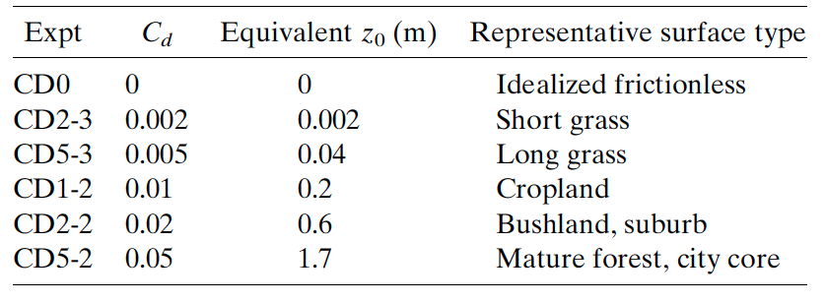
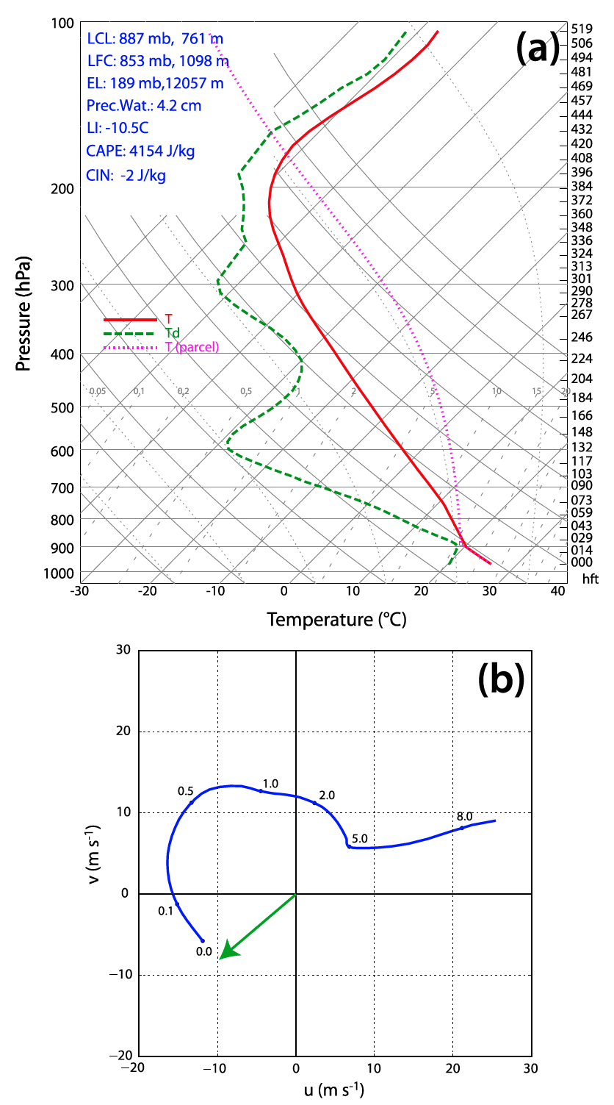
FIG. 1. (a) Skew-T Log-P plot, and (b) wind hodograph, representing sounding MAY3B, which is used to initialize all experiments in the present study. In (b), dots and their annotations represent heights AGL in km, and the green arrow emanating from the origin represents the ”ground-motion vector” (i.e., the vector which is 922 added to the base-state wind profile to obtain a quasi-stationary storm in the simulation). Adapted from R16.
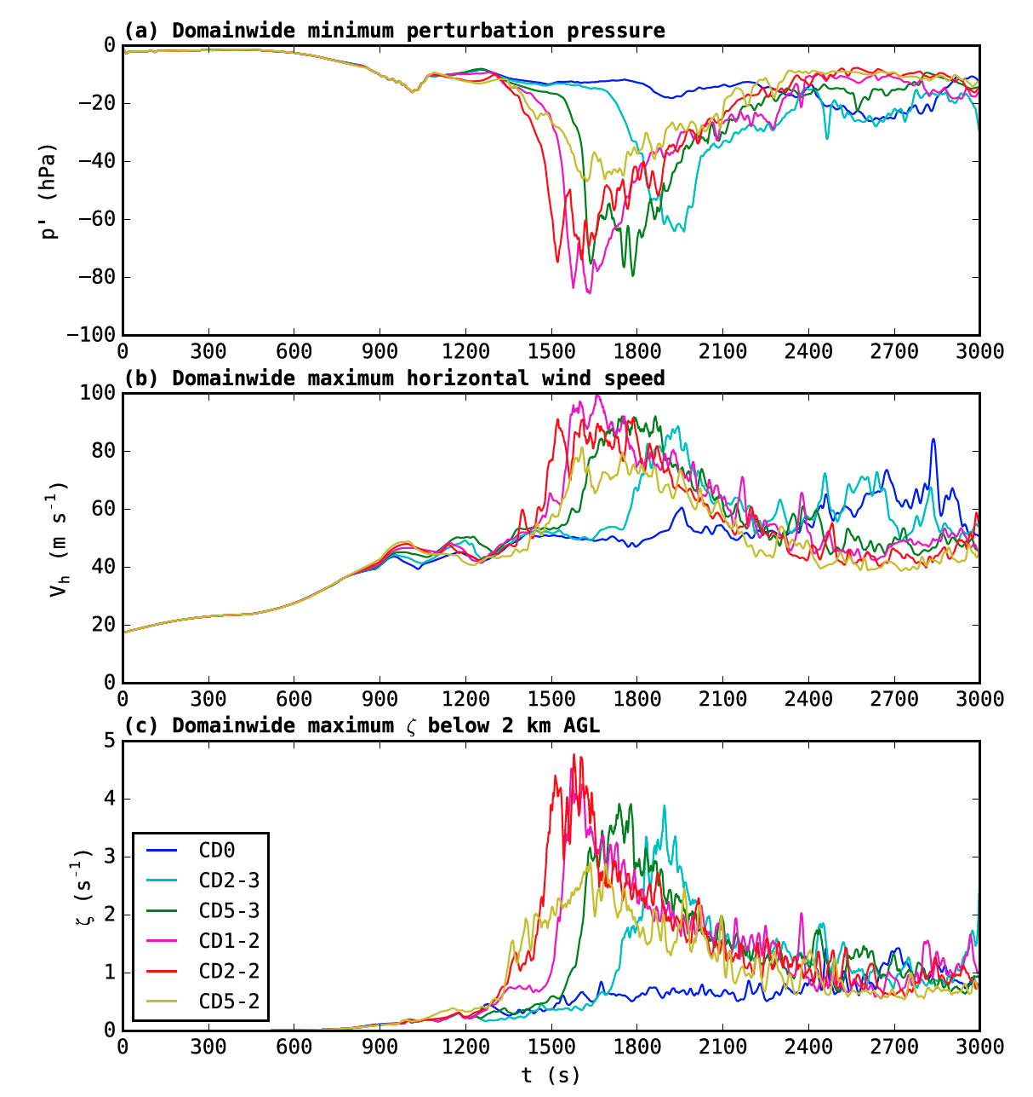
FIG. 2. Time series of domain-wide (a) minimum perturbation pressure, (b) maximum horizontal storm- relative wind speed, and (c) maximum vertical vorticity below 2 km AGL for the six GWB-based experiments between 0-3000 s.
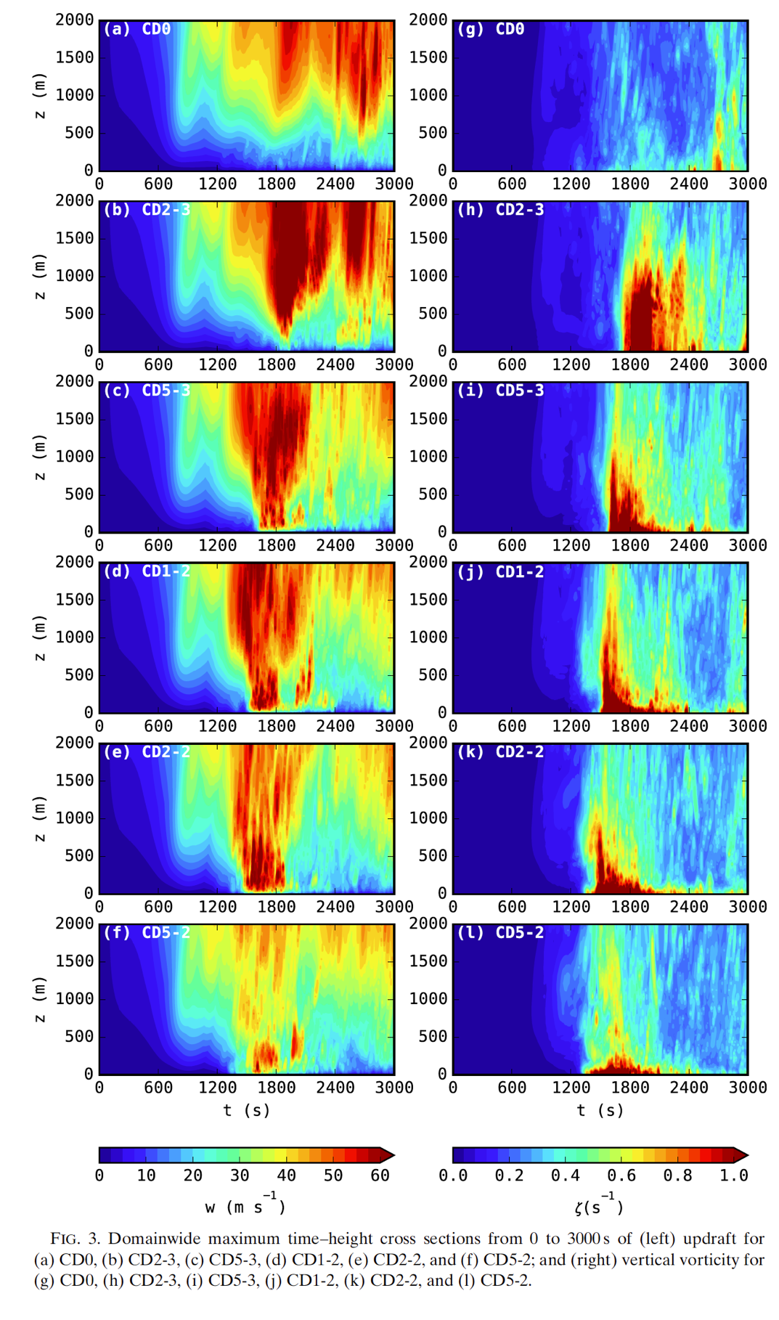
FIG. 3. Domain-wide maximum time-height cross sections from 0-3000 s of updraft for (a) CD0, (b) CD2-3, (c) CD5-3, (d) CD1-2, (e) CD2-2, and (f) CD5-2; and of vertical vorticity for (g) CD0, (h) CD2-3, (i) CD5-3, (j) CD1-2, (k) CD2-2, and (l) CD5-2.
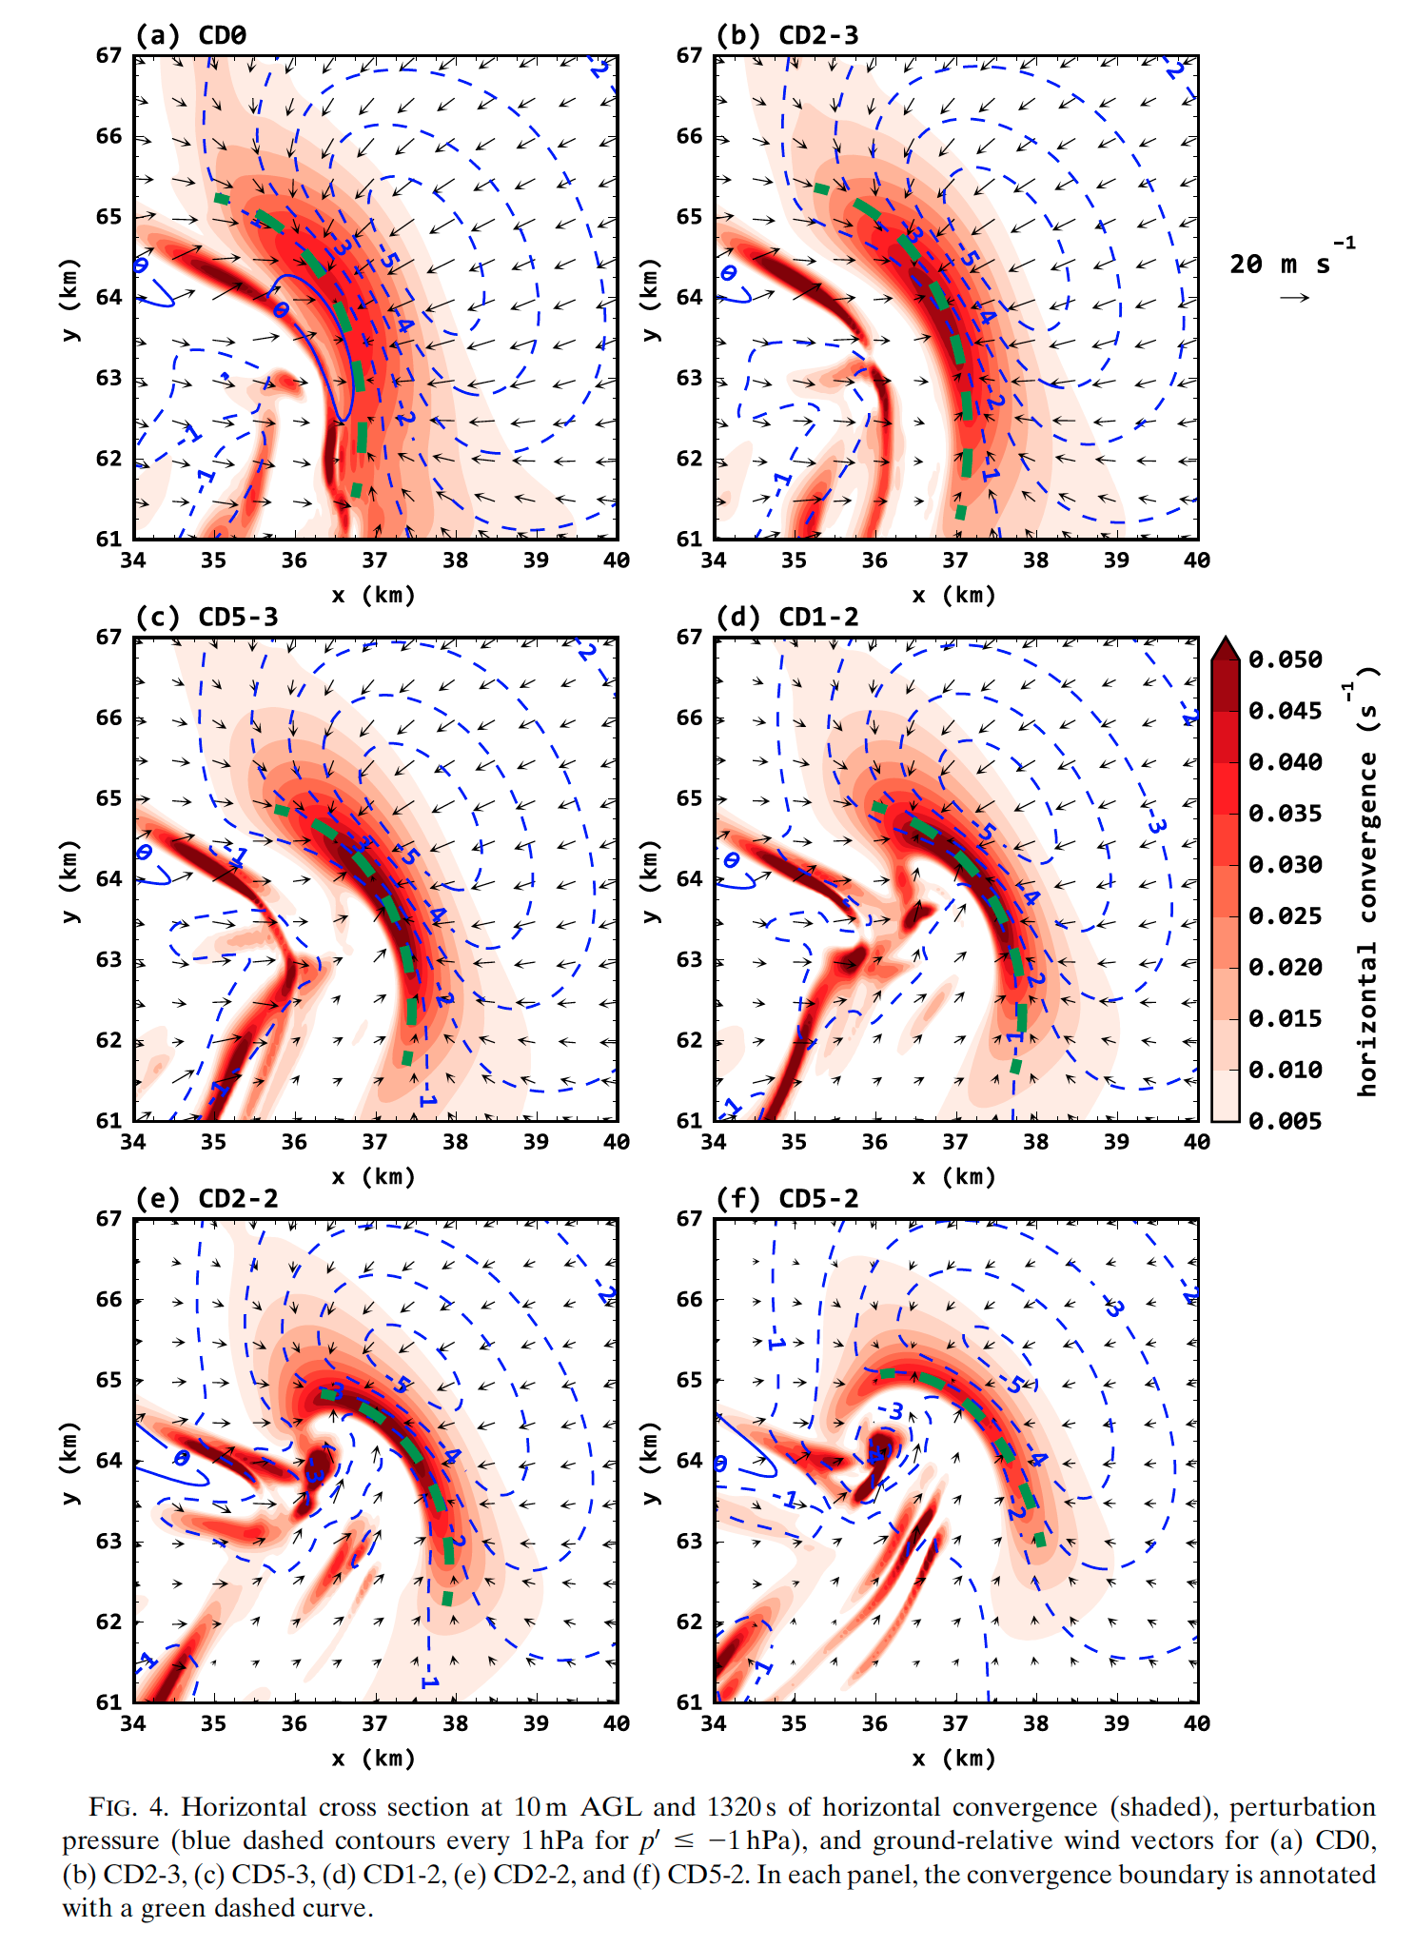
FIG. 4. Horizontal cross-section at 10 m AGL and 1320 s of horizontal convergence (shaded), perturbation pressure (blue dashed contours every 1 hPa for p^{t} ≤ -1 hPa), and ground-relative wind vectors for (a) CD0, (b) CD2-3, (c) CD5-3, (d) CD1-2, (e) CD2-2, and (f) CD5-2. In each panel, the convergence boundary is annotated
with a green dashed curve.
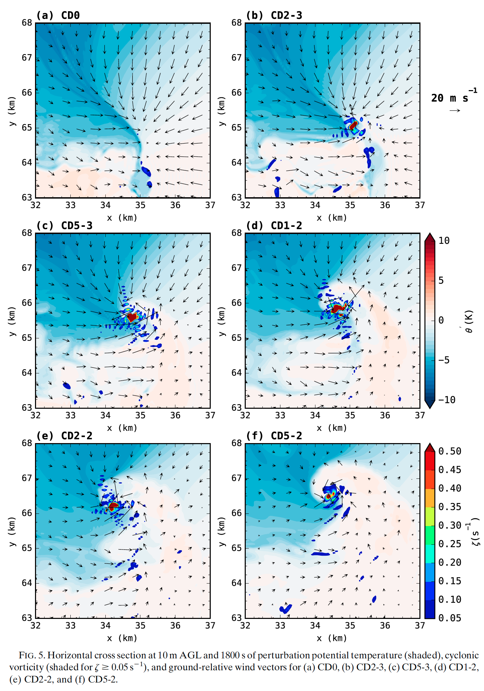
FIG. 5. Horizontal cross-section at 10 m AGL and 1800 s of perturbation potential temperature (shaded), cyclonic vorticity (shaded for ξ ≥ 0.05 s⁻¹), and ground-relative wind vectors for (a) CD0, (b) CD2-3, (c) CD5- 3, (d) CD1-2, (e) CD2-2, and (f) CD5-2.
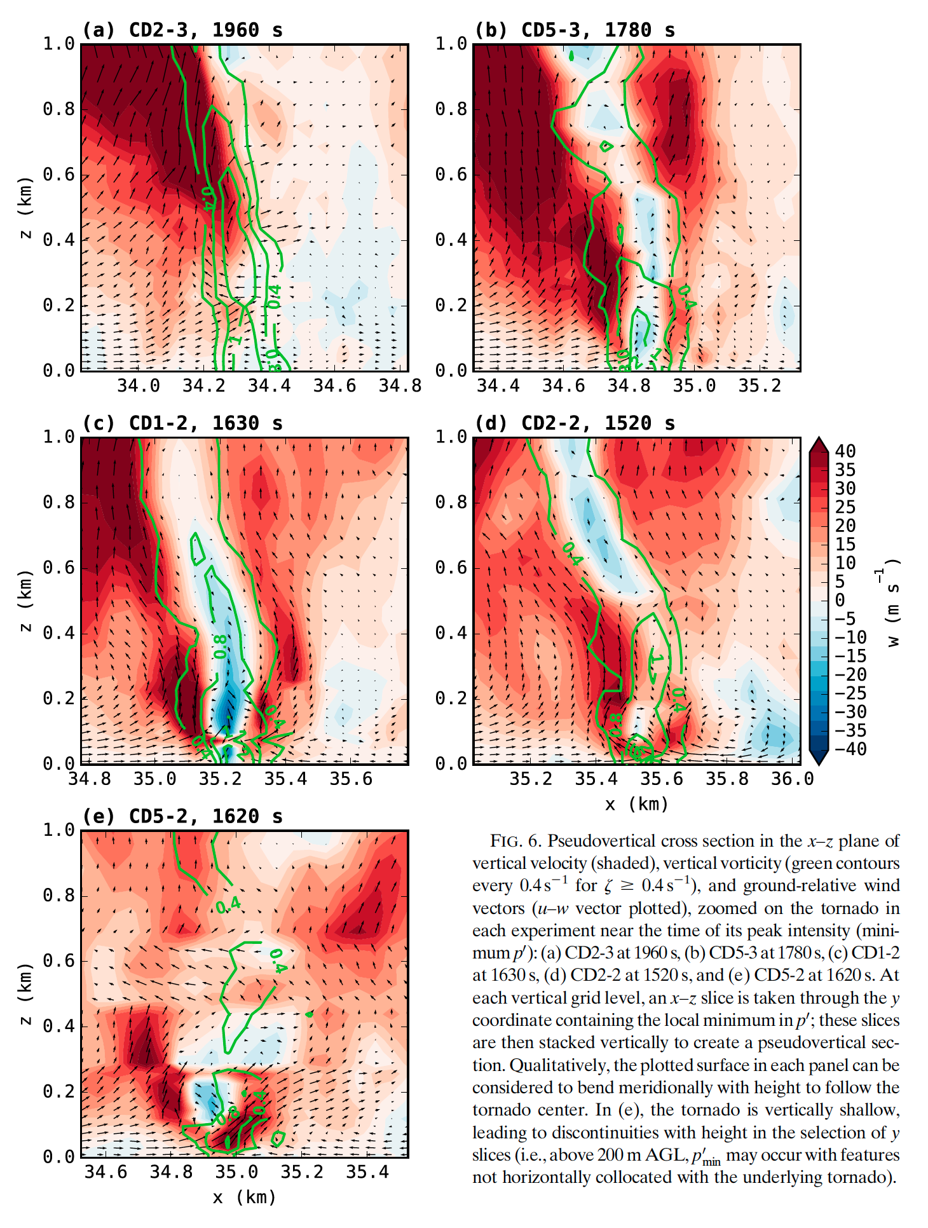
FIG. 6. Pseudo-vertical cross-section in the x-z plane of vertical velocity (shaded), vertical vorticity (green
contours every 0.4 s⁻¹ for ξ ≥ 0.4 s⁻¹), and ground-relative wind vectors (u-w vector plotted) zoomed on the tornado in each experiment near the time of its peak intensity (minimum p^{t}): (a) CD2-3 at 1960 s, (b) CD5-3 at 1780 s, (c) CD1-2 at 1630 s, (d) CD2-2 at 1520 s, and (e) CD5-2 at 1620 s. At each vertical grid level, an x-z slice is taken through the y-coordinate containing the local minimum in p^{t}; these slices are then stacked vertically to create a pseudo-vertical section. Qualitatively, the plotted surface in each panel can be considered to bend meridionally with height to follow the tornado center. In (e), the tornado is vertically shallow, leading to discontinuities with height in the selection of y-slices (i.e., above 200 m AGL, p^{t}min may occur with features not horizontally collocated with the underlying tornado).
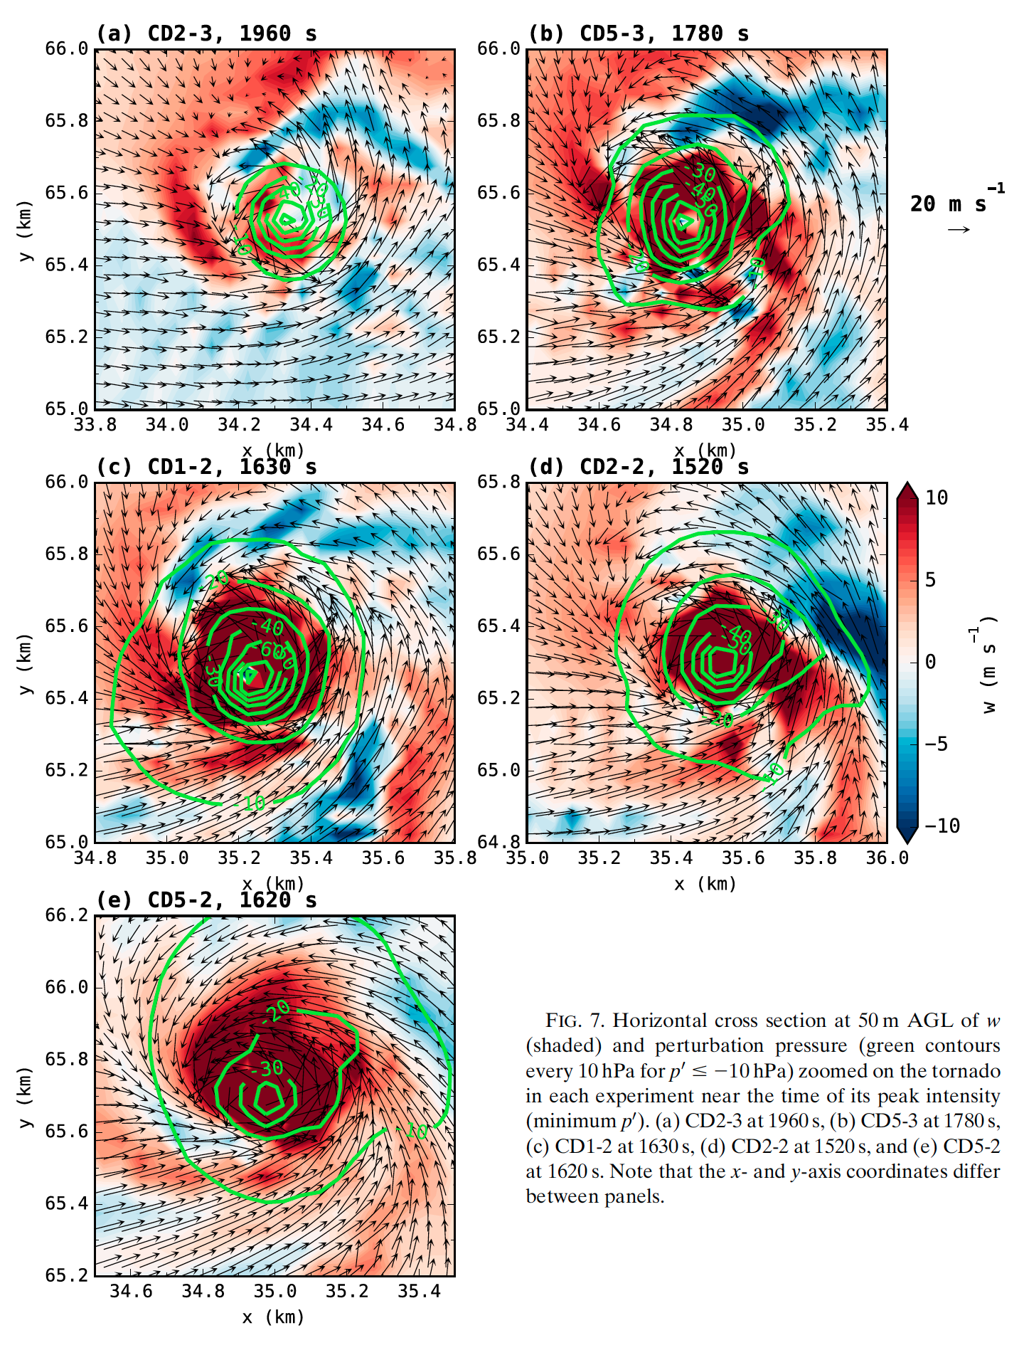
FIG. 7. Horizontal cross-section at 50 m AGL of w (shaded) and perturbation pressure (green contours every 10 hPa for p^{t} ≤ -10 hPa) zoomed on the tornado in each experiment near the time of its peak intensity (minimum p^{t}). (a) CD2-3 at 1960 s, (b) CD5-3 at 1780 s, (c) CD1-2 at 1630 s, (d) CD2-2 at 1520 s, and (e) CD5-2 at 1620s. Note that the x- and y-axis coordinates differ between panels.
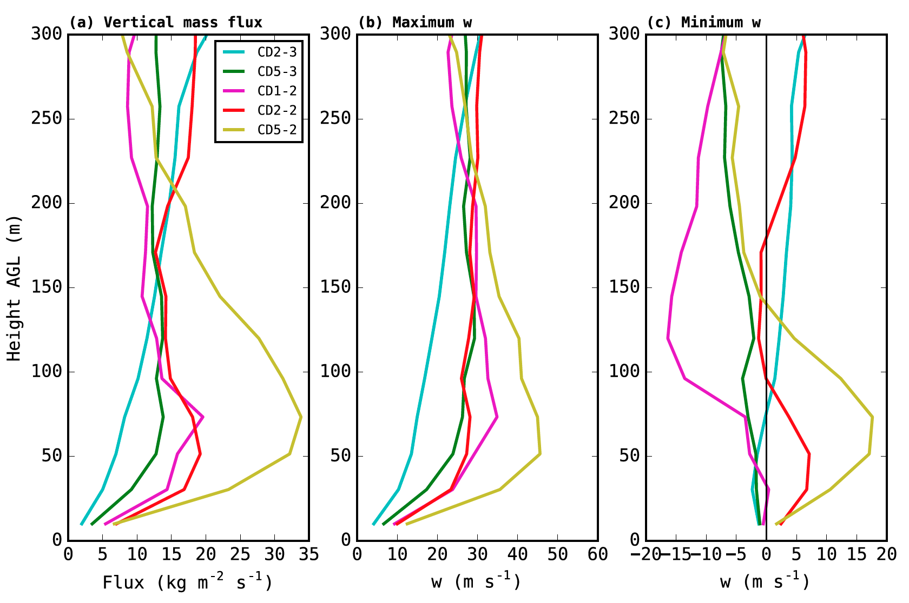
FIG. 8. Time-averaged vertical profiles of (a) vertical mass flux, (b) maximum w, and (c) minimum w within a 350x350 m box centered on the first tornado in each experiment (except CD0, which has no tornado during the initial mesocyclone cycle). At each vertical level and at each sampled time, the box is centered on the grid point with minimum p^{t} . For each experiment, the tornado is sampled at 10-s intervals over the minute leading up to the time of the minimum p^{t} . in Fig. 2 (1900-1960 s for CD2-3; 1720-1780 s for C5-3; 1570-1630 s for CD1-2; 1460-1520 s for CD2-2; 1560-1620 s for CD5-2).
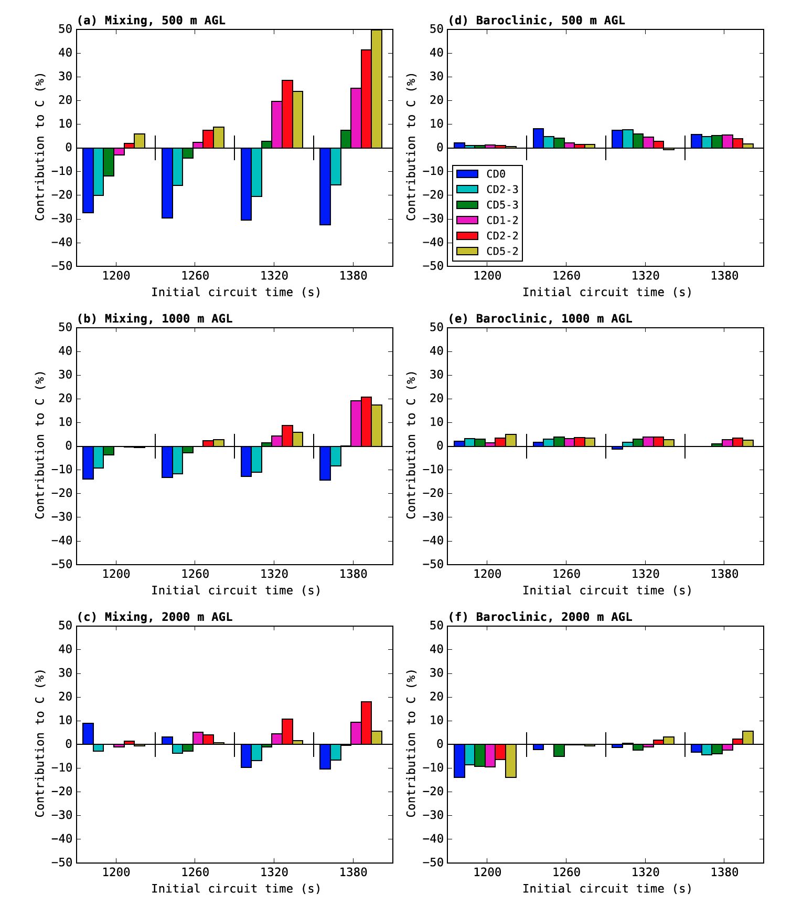
FIG. 9. Total contribution by the mixing generation term over the 10-min circulation budget integration window, normalized by the final value of circulation at the end of the window, for circuits initialized at (a) 500 m AGL, (b) 1000 m AGL, and (c) 2000 m AGL. (d-f) as in (a-c), but for the baroclinic generation term. Each panel is divided into four sections corresponding to the times labeled on the abscissa. These labels denote when the circuit in each experiment was initialized; the plotted contributions occurred over the 10-min period preceding this time.
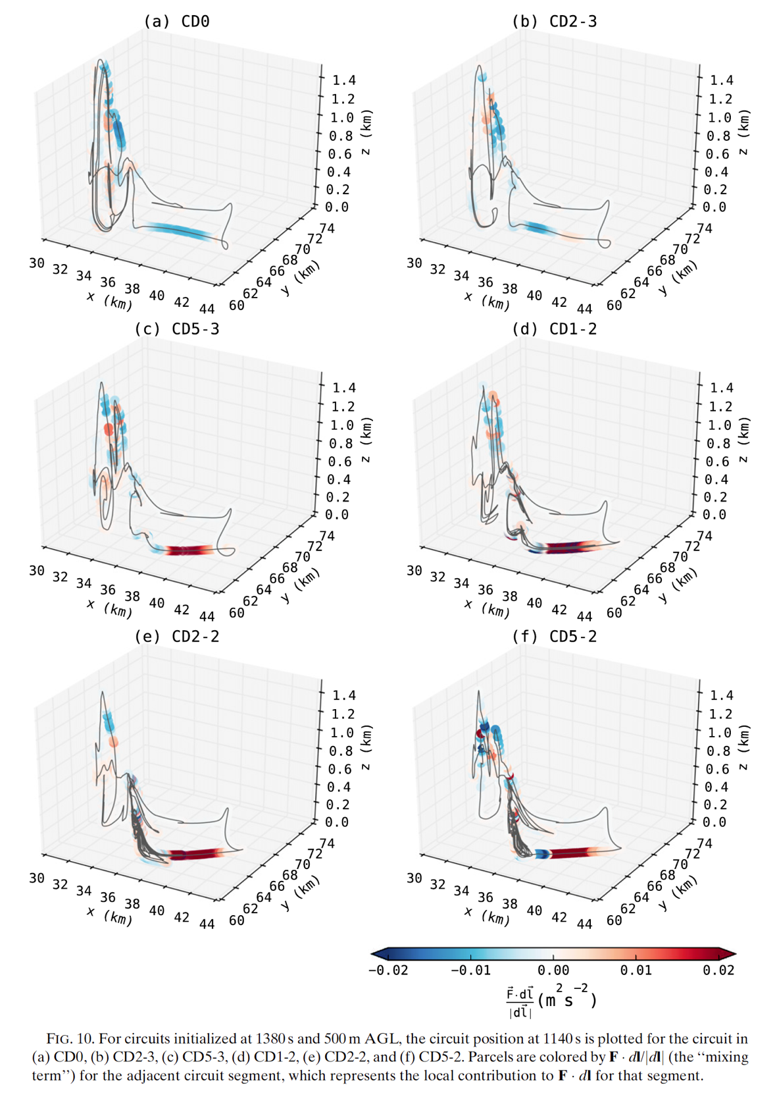
FIG. 10. For circuits initialized at 1380 s and 500 m AGL, the circuit position at 1140 s is plotted for the rcuit in (a) CD0, (b) CD2-3, (c) CD5-3, (d) CD1-2, (e) CD2-2, and (f) CD5-2. Parcels are colored by F ·dl (the
|dl|
mixing term) for the adjacent circuit segment, which represents the local contribution to F · dl for that segment.
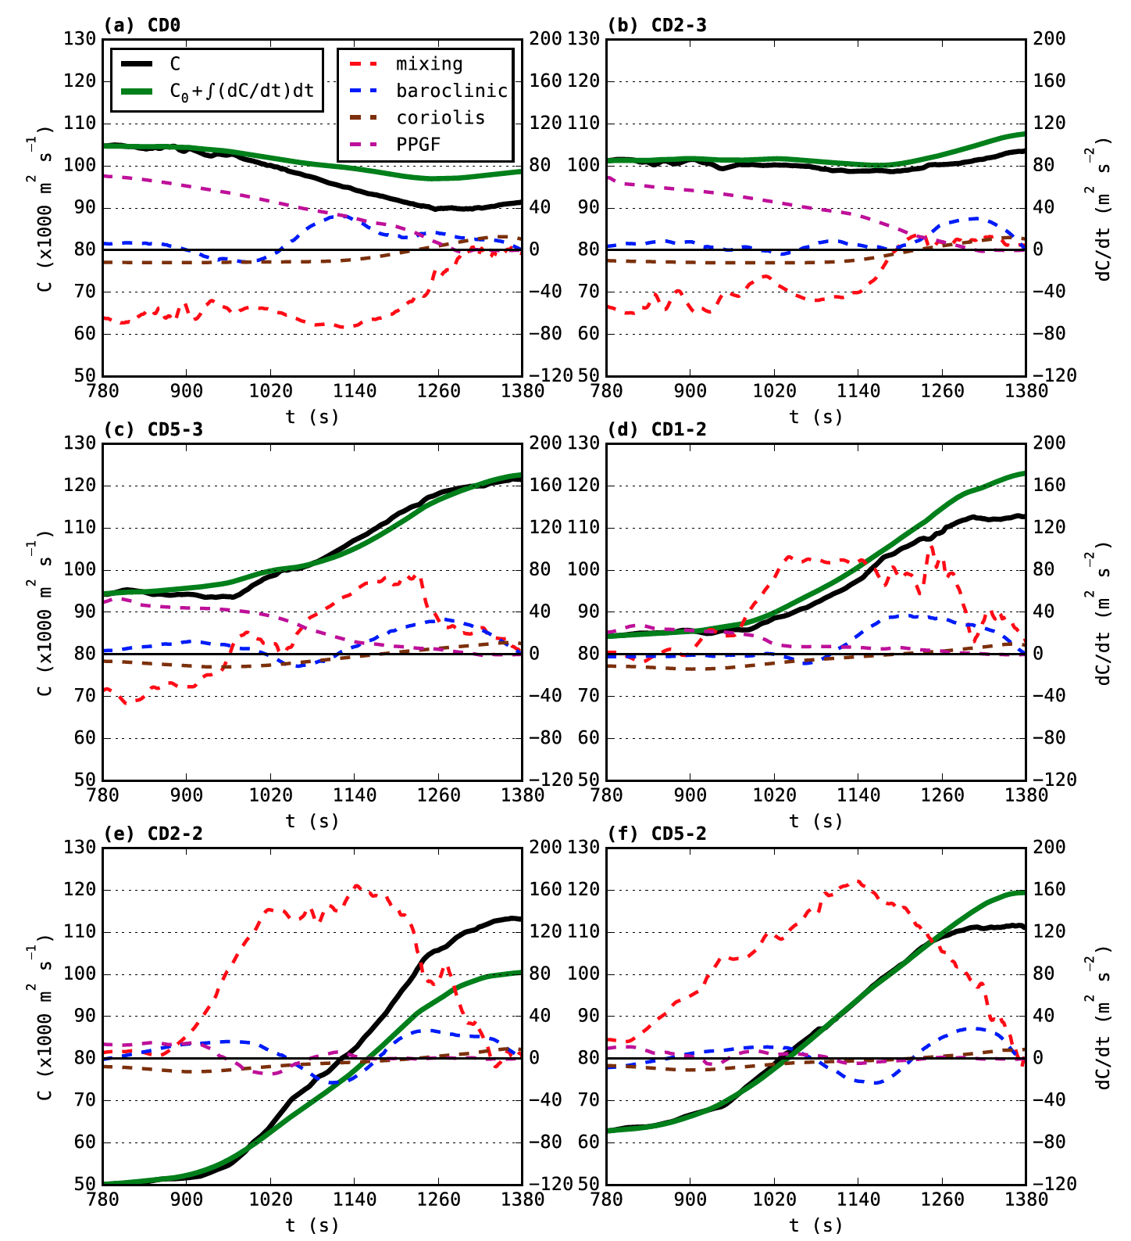
FIG. 11. Time series of interpolated circulation (solid black) and circulation integrated from forcing terms (solid green); and for the mixing (dashed red), baroclinic (dashed blue), Coriolis (dashed brown), and PPGF (dashed purple) forcing terms for the circuits in Fig. 10; (a-f) correspond to the circuits described therein. These circuits were each initialized at 1380 s and integrated backward 10 min in time (to 780 s). The left ordinate axis labels are for the interpolated and integrated circulation, while the right ordinate axis labels are for the forcing terms.

