Template for AMS Manuscript - Title

First Author¹ and Second Author^{1,2}

Center for Analysis and Prediction of Storms¹ and School of Meteorology²
University of Oklahoma, Norman Oklahoma 73072

Month, Year

Submitted to Monthly Weather Review

Corresponding author address:
Firstname Lastname
Center for Analysis and Prediction of Storms
University of Oklahoma,
120 David L. Boren Blvd, Norman OK 73072
email@ou.edu

Abstract
Body of abstract.

1. Introduction
Brief review of existing work. Motivation of current study. The main approach taken. The Advanced Regional Prediction System ARPS (ARPS, Xue et al. 2000; Xue et al. 2001; Xue et al. 2003) is used in this study.
The following illustrates several different ways references should be cited before Endnote Formatting. Xue et al. (2000) describe the dynamic framework of ARPS.
Numerical studies on dryline convective initiation have been performed recently (e.g., Xue and Martin 2006a, b; Liu and Xue 2008, XM06a, XM06b and LX08 respectively hereafter).
The above before the references are formatted look like the following. Refer to the Endnote User’s Guide, a PDF file you can find within the Endnote program folder, for additional instructions. Start by obtaining a latest version of Endnote library from Dr. Ming Xue.
Brief review of existing work. Motivation of current study. The main approach taken. The Advanced Regional Prediction System ARPS [ARPS, \Xue, 2000 #4923;Xue, 2001 #28632;Xue, 2003 #26683] is used in this study.
The following illustrates several different ways references should be cited before Endnote Formatting. Xue et al. [, 2000 #4923] describe the dynamic framework of ARPS.
Numerical studies on dryline convective initiation have been performed recently [e.g., \Xue, 2006 #31865;, 2006 #31917;Liu, 2008 #32249, XM06a, XM06b and LX08 respectively hereafter].
The rest of this paper is organized as follows. In section 2, the method is described. Section 3 describes the numerical experiments and section 4 discusses the results. Summary and conclusions are given in section 5.

2. Method – use Heading 1 style

a. Subsection title – use Heading 2 Style, do not manually change the title style
Body of section. The results of experiment are shown in Fig. 1. Use “Insert Cross-reference” to reference figures.

Sub-subsection tile – using Heading 3 Style

Sub-subsection 2 title

b. Subsection title– use Heading 2 Style, do not manually change the title style
Body of section.

3. Experimental design

a. Subsection title
Body of section.

b. Subsection title
Body of section.

4. Results and discussions

a. Subsection title
Body of section. Fig. 1 shows so and so.

b. Subsection title
Body of section. Fig. 2 shows so and so.

5. Summary and conclusions

Acknowledgement: This work was primarily supported by NSF grant ATM-000000.

References
Comment: Use Page Break to start a new page with references. Use Endnote to automatically create reference list.

Liu, H. and M. Xue, 2008: Prediction of convective initiation and storm evolution on 12 June 2002 during IHOP. Part I: Control simulation and sensitivity experiments. Mon. Wea. Rev., 136, 2261-2283.
Xue, M. and W. J. Martin, 2006a: A high-resolution modeling study of the 24 May 2002 case during IHOP. Part I: Numerical simulation and general evolution of the dryline and convection. Mon. Wea. Rev., 134, 149–171.
Xue, M. and W. J. Martin, 2006b: A high-resolution modeling study of the 24 May 2002 case during IHOP. Part II: Horizontal convective rolls and convective initiation. Mon. Wea. Rev., 134, 172–191.
Xue, M., K. K. Droegemeier, and V. Wong, 2000: The Advanced Regional Prediction System (ARPS) - A multiscale nonhydrostatic atmospheric simulation and prediction tool. Part I: Model dynamics and verification. Meteor. Atmos. Physics, 75, 161-193.
Xue, M., D.-H. Wang, J.-D. Gao, K. Brewster, and K. K. Droegemeier, 2003: The Advanced Regional Prediction System (ARPS), storm-scale numerical weather prediction and data assimilation. Meteor. Atmos. Physics, 82, 139-170.
Xue, M., K. K. Droegemeier, V. Wong, A. Shapiro, K. Brewster, F. Carr, D. Weber, Y. Liu, and D. Wang, 2001: The Advanced Regional Prediction System (ARPS) - A multi-scale nonhydrostatic atmospheric simulation and prediction tool. Part II: Model physics and applications. Meteor. Atmos. Phys., 76, 143-166.

List of figures
Comment: Use Insert Table of Figures to automatically generate the list below from figure captions.

Fig. 1. The 3-km model domain with shaded terrain elevation contours. The nested 1-km domain is indicated by the rectangular box which used a separate higher-resolution terrain definition. The 1-km grid shares the south boundary with the 3-km one. Letters A, L, S, C, H, F and O in the figure indicate the locations of Amarillo, Lubbock, Shamrock, Childress in Texas; and Hollis, Frederick and Oklahoma City in Oklahoma. Also shown are county and state boundaries.
Fig. 2. As in Fig. 1, but …. Use Insert Cross-reference to reference a figure.
Fig. 3. Figure 3 caption.
Fig. 4. Figure 4 caption.
Fig. 5. Figure 5 caption.

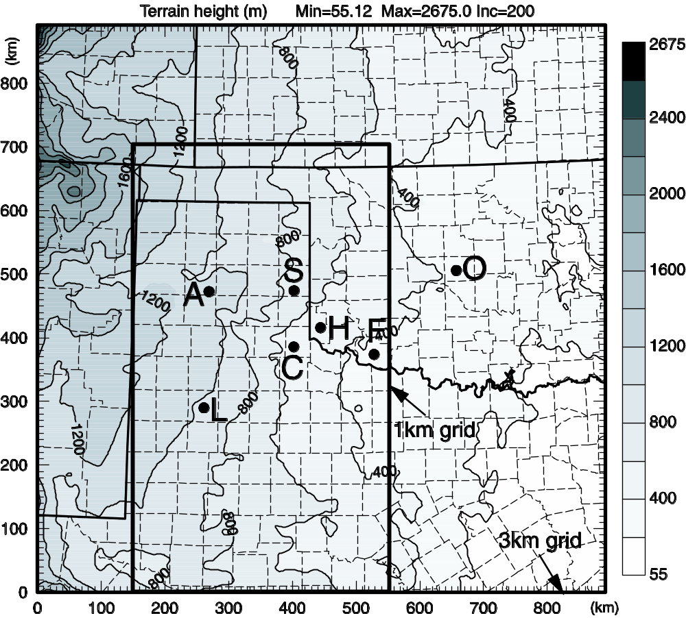
Fig. 1. The 3-km model domain with shaded terrain elevation contours. The nested 1-km domain is indicated by the rectangular box which used a separate higher-resolution terrain definition. The 1-km grid shares the south boundary with the 3-km one. Letters A, L, S, C, H, F and O in the figure indicate the locations of Amarillo, Lubbock, Shamrock, Childress in Texas; and Hollis, Frederick and Oklahoma City in Oklahoma. Also shown are county and state boundaries.

Comment: Use Insert Caption to create automatically number of captions. Create New Label ‘Fig.’ if it does not already exist. It does not by default in Word. Use EPS format figures whenever possible. Use Adobe Illustrator to touch up the figure and to add labels etc. Use Postscript version of ARPSPLT/ZXPLOT if possible. The character strings will be editable in PS format, and the fonts look nicer.

Fig. 2. As in Fig. 1, but …. Use Insert Cross-reference to reference a figure.

Use Insert Page Break to separate figures into separate pages. Reference the figures using Insert/Reference/Cross-reference, such as the reference to Fig. 1 here.

Table 1. Table 1 caption. Use Insert Caption to create table captions.

Fig. 3. Figure 3 caption.

Fig. 4. Figure 4 caption.

Fig. 5. Figure 5 caption.

